**TOS PROTOCOL AND PROCEDURE:**  
**MEASUREMENT OF VEGETATION STRUCTURE**

|  |  |  |
| --- | --- | --- |
| **PREPARED BY** | **ORGANIZATION** | **DATE** |
| Courtney Meier | SCI |  |
| Katherine Jones | SCI |  |

|  |  |  |
| --- | --- | --- |
| **APPROVALS** | **ORGANIZATION** | **APPROVAL DATE** |
| Andrea Thorpe | SCI |  |
| Mike Stewart | SYS |  |
|  |  |  |
|  |  |  |

|  |  |  |
| --- | --- | --- |
| **RELEASED BY** | **ORGANIZATION** | **RELEASE DATE** |
| Judy Salazar | CM |  |

See configuration management system for approval history.

The National Ecological Observatory Network is a project solely funded by the National Science Foundation and managed under cooperative agreement by Battelle. Any opinions, findings, and conclusions or recommendations expressed in this material are those of the author(s) and do not necessarily reflect the views of the National Science Foundation.

**Change Record**

| **REVISION** | **DATE** | **ECO #** | **DESCRIPTION OF CHANGE** |
| --- | --- | --- | --- |
| A | 01/10/2014 | ECO-01139 | Initial release |
| B | 03/20/2014 | ECO-01661 | Production release, template change, and other changes as detailed in Appendix C |
| C | 4/10/2014 | ECO-01792 | Added Appendix H with site-specific information |
| D | 10/01/2014 | ECO-02287 | Migration to new template. Reorganization of content and updates to datasheets. Change to sampling strategy in 40 m x 40 m Tower plots. |
| E | 02/25/2015 | ECO-02537 | Update of TOS protocol based on 2014 field experience and budget analysis. |
| F | 02/29/2016 | ECO-03583 | Summary of protocol changes:   * Updated key definitions in Section 2.4 Table 1, and added growth form definitions in Section B.1 Table 7 * Section 4.1: Clarified timing language for fern sampling * SOP B: Reorganized to focus only on classification, mapping, and tagging. Flow charts, figures, and information pertaining to measurements removed and inserted to SOP C when appropriate. * SOP B.1: Classification to growthForm now dependent on stem count, DBH, height, and species-specific knowledge * SOP B.2: Nested subplot text moved from SOP C to SOP B * SOP B.2: Added mechanism to change nested subplot size in consultation with NEON Science Operations. * SOP B.3: ‘Selecting the Optimal Measurement Area’ moved from SOP C to SOP B. * SOP B.5: Added standardized taxonID text to step 9 * SOP C.1: Broken bole measurement strategy no longer requires confusing data entry into canopy diameter fields. * SOP C.3: Cactus measurements removed, moved to newly developed Cactus SOP (RD[11]) * SOP C.4: Calipers now required for diameter measurements on self-supporting stems with lianas. Multi-bole tree measurement strategy now consistent with FIA approach, no longer based on liana guidelines. * SOP C.8: Changed ‘stemStatus’ to ‘status’, updated code definitions, added a new code for ‘no longer measured’ * SOP C.11: Added paragraph calling out types of ‘other’ growth forms that require measurement, provided cross-reference to Appendix D for details. * SOP E: Added standardized data entry text * Appendix: Removed *Toxicodendron* handling appendix, due to imminent release of *Toxicodendron* handling SOP. |
| G | MM/DD/2016 | ECO- | Summary of protocol changes:   * Section 2.3: Updated definitions for acronymns. * Sampling completion: Specified that bouts must be completed within 4 months of sampling onset. * Expanded instructions for recording Plot Metadata, and changed to annual basis to improve tracking and reporting of sampling effort. * Updated numerous field names to be consistent with Data Products implementation. * Added `tagStatus` to facilitate tracking individuals through time, including a ‘removed’ option to account for removing tags from downed individuals. * Added guidance for removing tags when a tree falls over * Added guidance to avoid plot centroid if at all possible during mapping and tagging. * Changed `status` to `plantStatus` to comply with pre-existing Data Products term definitions, and added new plantStatus choices. * Clarified existing broken bole guidance, and expanded to additional growth forms. * To address problem with consistent field implementation, shrub ‘shape’ no longer limited to leafy crown, now consider the entire individual. * Appendix D.2: Updated forking guidelines to be consistent with 2016 Forest Service FIA rules. * Appendix D.5: Clarified that ddh is not measured if access is denied along first 30 cm of stem. * Appendix D.6: Added measurement guidelines for multi-bole and mixed-status ‘sap’ and ‘sms’ individuals. * Appendix F: Clarified that agave and other yucca-like growth forms with large basal rosettes should be measured similar to yucca. * Appendix H: Converted dates from DOY to MM/DD * Appendix I: Added OS/Ops-IPT approved site-specific modifications related to Operations Efficiencies. |

TABLE OF CONTENTS

1 Overview 1

1.1 Background 1

1.2 Scope 1

1.2.1 NEON Science Requirements and Data Products 1

1.3 Acknowledgments 1

2 Related Documents and Acronyms 2

2.1 Applicable Documents 2

2.2 Reference Documents 2

2.3 Acronyms 3

2.4 Definitions 3

3 Method 4

4 Sampling Schedule 6

4.1 Sampling Frequency and Timing 6

4.2 Criteria for Determining Onset and Cessation of Sampling 7

4.2.1 Sites with No Distinct Growing Season 7

4.3 Timing for Laboratory Processing and Analysis 7

4.4 Sampling Timing Contingencies 7

4.5 Criteria for Permanent Reallocation of Sampling within a Site 8

5 Safety 9

6 Personnel and Equipment 10

6.1 Equipment 10

6.2 Training Requirements 19

6.3 Specialized Skills 19

6.4 Estimated Time 19

7 Standard Operating Procedures 20

SOP A Preparing for Sampling 21

A.1 Preparing for Data Capture 21

A.2 Office tasks 21

A.3 Checking the laser rangefinder 21

A.4 Data sheet preparation 22

SOP B Classification, Mapping, and Tagging 23

B.1 Classifying Woody Vegetation to Growth Form 23

B.2 Using nested subplots to standardize the sampling effort 27

B.3 Selecting the optimal measurement area 28

B.4 Mapping and tagging requirements by growth form 33

B.5 Stem mapping, tagging, and taxon identification 38

SOP C Biomass/Productivity Measurements 43

C.1 Measuring Apparent Individuals 44

C.2 Measuring Shrub Groups and Liana Groups 57

C.3 Measuring ‘Other’ growth forms 58

SOP D Field Campaign Follow-up 60

D.1 Sample preservation 60

D.2 Refreshing the sampling kit 60

D.3 Equipment maintenance, cleaning, and storage 60

SOP E Data Entry and Verification 61

8 References 62

Appendix A Datasheets 63

Appendix B Quick References 64

B.1 Quick Reference: Making Quality Measurements of Woody Vegetation Structure 64

Appendix C Reminders 65

Appendix D Woody Stem Measurement Guidelines 66

D.1 Irregular Boles 66

D.2 Multi-bole Individuals and Stem Diameter Measurement 68

D.3 Live Downed Trees 70

D.4 Mixed Status Individuals 72

D.5 Shrubs 74

D.6 Saplings and Small Shrubs 75

Appendix E Liana Measurement Guidelines 76

Appendix F Guidelines for measuring ‘Other’ Vegetation 78

Appendix G Plot Map 79

Appendix H Estimated Dates for Onset and Cessation of Sampling 80

Appendix I Site-Specific Modifications 84

I.1 Domain 18 84

I.2 Domain 19 85

**LIST OF TABLES**

**Table 1**. Definitions for common terms used throughout the Vegetation Structure protocol. 3

**Table 2.** Contingency guidelines and possible outcome for data product quality. 8

**Table 3.** Equipment list – Preparing for sampling (SOP A). 10

**Table 4.** Equipment list – Mapping and tagging (SOP B). 11

**Table 5.** Equipment list – Biomass/productivity measurements* (SOP C). 14

**Table 6.** Equipment and materials required for a team of two to minimize exposure to toxic oils from *Toxicodendron spp.* 18

**Table 7**. Growth forms into which woody vegetation is classified, and their definitions. Parentheses following the terms in the list below indicate the 3-letter code used for classifying particular defined growth forms. 24

**Table 8**. List of supported subplot and nested subplot dimensions that vary with plot size. The decision to use nested subplots is made on a per plot basis, and allows standardization of sampling effort across plots. 27

**Table 9.** Summary of mapping and tagging requirements for each growth form. 34

**Table 10.** Guidelines for determining the appropriate measurement and tagging location for situations not covered in Table 9. 37

**Table 11.** identificationQualifier codes for species ID. Leave this field blank if technician is confident in the genus and species ID. 41

**Table 12**. Summary of required measurements for each growth form; it is assumed that required taxonomic data are recorded on the ‘Mapping and Tagging’ datasheet as part of SOP B implementation. Note that individuals may change growthForm from one year to the next, necessitating potentially different measurements (e.g., a change from ‘sapling’ to ‘small tree’). 44

**Table 13.** List of **plantStatus** codes and their definitions. 49

**Table 14**. Canopy position definitions. Modified from USFS Forest Inventory Analysis program Crown Class definitions to emphasize an individual’s visibility to AOP remote-sensing instruments (U.S. Forest Service 2012). 53

**Table 15**. Idealized shapes for volume estimation. 54

**Table 16**. Fern and fern ally morphology groups, and associated required measurements. 59

**Table 17.** Datasheets associated with this protocol 63

**Table 18.** Site-specific sampling start and end dates for vegetation structure measurements 80

**LIST OF FIGURES**

**Figure 1.** Generalized TOS sampling schematic, showing the placement of Distributed, Tower, and Gradient Plots. 5

**Figure 2.** A 20m × 20m base plot (left; larger destructive sampling portion of the plot not shown), a 40m × 40m base plot (right), and associated nested subplots used for measuring woody stem vegetation. The 20m x 20m plot size may be used for either Distributed Plots or Tower Plots, and the 40m x 40m plot size is only for Tower Plots. Numbers in plain grey text indicate subplotIDs and numbers in italic black text indicate nested subplotIDs. The pointIDs associated with markers (red circles) are provided in Appendix G. 5

**Figure 3**. High-level classification tree for assigning vegetation to growth form, and assigning the correct protocol. 26

**Figure 4**. Decision tree indicating how structural observations and stem diameter data inform the classification of apparent individuals to growth form. Dashed lines call out points where growth form classification may change after considering height and species-specific information. 26

**Figure 5.** Example of graph paper method for determining shrub group area within a 20 m x 20 m subplot. In this example, **canopyArea** = 41. 57

**Figure 6**. Guidelines for determining where to measure liana stem diameter (red line) across a variety of complex growth forms. Different growth forms correspond to capital letters, and are described more fully below. Cases A-G (top panel) are commonly encountered, and cases H-R (bottom panel) are less common. 76

**Figure 7.** Plot map, illustrating how NEON base plots of various sizes are constructed from 10 m x 10 m ‘modules.’ The SW corner of each ‘module’ receives a pointID number; bold numbers indicate pointIDs that may receive physical markers and for which high-resolution GPS data may be collected. 79

# Overview

## Background

The measurement of vegetation structure and the mapping of free-standing woody stems is an important complement to data streams generated by the NEON Airborne Observation Platform (AOP) and Terrestrial Instrument System (TIS). These ground-collected data will validate LiDAR data used to map the structural complexity of vegetation, and will enable mapping of plant biomass at the site scale. In conjunction with carbon flux data, vegetation structure data will facilitate understanding how biomass in different plant growth forms contributes to ecosystem level carbon flux.

This protocol is designed to measure key aspects of vegetation structure that are directly comparable to airborne LiDAR observations, as well as additional structural metrics that enable estimation of per stem and per plot plant biomass and productivity. These measurements include: stem diameter(s), crown diameter(s), total height, mapped location (for stems that meet certain criteria), taxon identification, and plant status (i.e. healthy, dead, or damaged).

There are numerous methods for measuring and mapping woody stems. The recommended procedure depends greatly on available resources, ecosystem type, and the intended application of resulting datasets. The overarching goal of this protocol is to utilize methods that are robust across a wide-variety of field conditions and ecosystem types, are relatively easy to implement in the field, are not prone to user error, are capable of producing high-quality data, and integrate well with existing similar datasets.

## Scope

This document provides a change-controlled version of Observatory protocols and procedures. Documentation of content changes (i.e. changes in particular tasks or safety practices) will occur via this change-controlled document, not through field manuals or training materials.

### NEON Science Requirements and Data Products

This protocol fulfills Observatory science requirements that reside in NEON’s Dynamic Object-Oriented Requirements System (DOORS). Copies of approved science requirements have been exported from DOORS and are available in NEON’s document repository, or upon request.

Execution of this protocol procures samples and/or generates raw data satisfying NEON Observatory scientific requirements. These data and samples are used to create NEON data products, and are documented in the NEON Scientific Data Products Catalog (RD[03]).

## Acknowledgments

Benjamin Chemel, of the Northern Rockies Conservation Cooperative, contributed substantially to the initial development and testing of this protocol, and NEON Field Operations technicians have been invaluable with respect to subsequent revision and refinement.

# Related Documents and Acronyms

## Applicable Documents

Applicable documents contain higher-level information that is implemented in the current document. Examples include designs, plans, or standards.

|  |  |  |
| --- | --- | --- |
| AD[01] | NEON.DOC.004300 | EHSS Policy, Program and Management Plan |
| AD[02] | NEON.DOC.004316 | Operations Field Safety and Security Plan |
| AD[03] | NEON.DOC.000724 | Domain Chemical Hygiene Plan and Biosafety Manual |
| AD[05] | NEON.DOC.050005 | Field Operations Job Instruction Training Plan |
| AD[06] | NEON.DOC.000914 | NEON Science Design for Plant Biomass, Productivity, and Leaf Area Index |
| AD[07] | NEON.DOC.004104 | NEON Science Performance QA/QC Plan |
| AD[08] | NEON.DOC.001155 | NEON Training Plan |

## Reference Documents

Reference documents contain information that supports or complements the current document. Examples include related protocols, datasheets, or general-information references.

|  |  |  |
| --- | --- | --- |
| RD[01] | NEON.DOC.000008 | NEON Acronym List |
| RD[02] | NEON.DOC.000243 | NEON Glossary of Terms |
| RD[03] | NEON.DOC.002652 | NEON Level 1, Level 2, and Level 3 Data Products Catalog |
| RD[04] | NEON.DOC.001271 | NEON Protocol and Procedure: Manual Data Transcription |
| RD[05] | NEON.DOC.001573 | Datasheets for TOS Protocol and Procedure: Measurement of Vegetation Structure |
| RD[06] | NEON.DOC.014037 | TOS Protocol and Procedure: Measurement of Herbaceous Structure and Biomass |
| RD[07] | NEON.DOC.014042 | TOS Protocol and Procedure: Plant Diversity Sampling |
| RD[08] | NEON.DOC.001025 | TOS Protocol and Procedure: Plot Establishment |
| RD[09] | NEON.DOC.001717 | TOS Standard Operating Procedure: TruPulse Rangefinder Use and Calibration |
| RD[10] | NEON.DOC.002150 | NEON Algorithm Theoretical Basis Document: TOS Vegetation Structure – QA/QC of Raw Field Data |
| RD[11] | NEON.DOC.001715 | TOS Standard Operating Procedure: Cactus Biomass and Handling |
| RD[12] | NEON.DOC.001716 | TOS Standard Operating Procedure: Toxicodendron Biomass and Handling |

## Acronyms

|  |  |
| --- | --- |
| **Acronym** | **Definition** |
| BH | Breast height; defined here as 130 cm above the ground, or 130 cm along the pith for curved, leaning, or decumbent individuals. |
| DBH | Diameter at breast height; the stem diameter measured 130 cm above the ground, or 130 cm along the pith for curved, leaning, or decumbent individuals. |
| ddh | Diameter at decimeter height – i.e., the stem diameter 10 cm above the ground, or 10 cm along the pith for curved, leaning, or decumbent individuals. |
| Ha | hectare; a unit of land area that is 100 m on a side (10,000 m2) |
| LAI | Leaf Area Index; the amount of one-sided leaf area per unit ground area (m2/m2) |
| LiDAR | Light Detection and Ranging; a remote-sensing technique commonly employed to measure vegetation structure from aircraft or from the ground. |
| NEE | Net Ecosystem Exchange; the net exchange or flux of carbon into or out of an ecosystem due to photosynthesis after accounting for losses due to ecosystem respiration. |
| NEP | Net Ecosystem Productivity; the net amount of material produced by an ecosystem per unit time, after accounting for losses due to ecosystem respiration. |
| NPP | Net Primary Productivity; the net amount of material produced by a plant via photosynthesis after subtracting the amount used by the plant’s own metabolism in a given unit of time. Typically reported as kg ha-1 y-1 or g m-2 y-1. |

## Definitions

Common terms used throughout this document are defined here, in alphabetical order. Criteria for defining trees, saplings and shrubs generally follow those outlined and adopted by the USDA PLANTS database.

**Table 1**. Definitions for common terms used throughout the Vegetation Structure protocol.

| **Term** | **Definition** |
| --- | --- |
| apparent individual | A stem or group of stems that form(s) an individual with a crown that is discernable from other apparent individuals. Apparent individuals may have multiple stems, provided they are clearly connected above, at, or just below ground level. The word “individual” here does not refer to “genetic” individuals. For example, in an Aspen clone, many apparent individuals are all part of one genetic individual, and each apparent individual is measured. |
| bole | Typically, the trunk of a tree. A bole differs from a lateral branch in that it is a primary support structure for the individual, supports lateral branches, and tends toward the canopy at angles < 45˚ off of vertical (although the latter is not true for decumbent growth forms). |
| emergent bole / stem | Part of a multi-bole tree or shrub that comes out of the ground separate from other boles, but is attached to the root collar either at or below ground level. Throughout the protocol, ‘bole’ is used for larger ‘sbt’, ‘mbt’, ‘sis’ and ‘smt’ individuals, and ‘stem’ is used for smaller ‘sap’ and ‘sms’ individuals. |
| overstory | The overstory is typically formed by the tallest individuals in the plot, and overstory individuals are often mapped. |
| primary bole / stem | A stem that supports smaller stems and lateral branches, and is not itself connected to a larger branch or bole. Often emerges from the ground and is connected directly to the root system. |
| qualifying bole / stem | A stem that meets listed criteria for a given growth form, and is measured according to this protocol. |
| understory | Relatively small-stature vegetation, either woody stemmed or herbaceous, that exists in the presence of an overstory. |
| woody stem | Lignified aboveground tissue that persists from year to year, typically increasing in diameter due to the addition of new secondary woody growth as the plant ages. |

# Method

A combination of NEON Distributed, Gradient, and Tower Plots will be used for collecting vegetation structure data (**Figure 1** and **Figure 2**). These ground datasets will enable calibration and validation of annually generated LiDAR datasets, and in conjunction with the AOP data, will form the basis for LiDAR-derived data products at the site and regional scales (e.g. site and regional LAI and plant biomass estimates).

In forested systems, vegetation structure data collected in the Tower Plots will constitute an important component of biomass and productivity estimation within the NEON Tower footprint, and will allow researchers to understand how tower-based measurements of ecosystem productivity correspond with finer-grained field-based assessments of net primary production by growth form. Because field-collected vegetation structure data are integrated with other measurement platforms (i.e. the NEON AOP and TIS), it is very important that the mapping and measurement of woody stems is performed with care, and in a repeatable fashion.

This field procedure is designed to generate data that describe the structure, spatial location, and biomass of the woody-stemmed plant community, including tree, sapling/shrub, liana, and ‘other’ growth forms. Stem mapping activities and the collection of vegetation structure data will take place in Distributed and Tower Plots, and may also take place in Gradient Plots if Gradient Plots are required at a given site. If required, Gradient Plot sampling will not take place until at least the field season after the first AOP overflight of a site has occurred. The procedure provides detailed guidelines for measuring the following key parameters:

* stem diameter (Diameter at Breast Height, DBH; and diameter at decimeter height, ddh)
* total stem height
* crown diameter
* taxonID
* plant status (i.e. healthy, snag, damaged, etc.), and
* the location of measured stems

Parameters such as DBH, ddh, crown diameter and total stem height can then be used to estimate aboveground biomass and carbon (C) density values, on both a per stem and a per unit area basis, as well as volume for some growth forms. All of the data collected according to this protocol are acquired with hand-held tools in the field, and there is no laboratory component to the work.

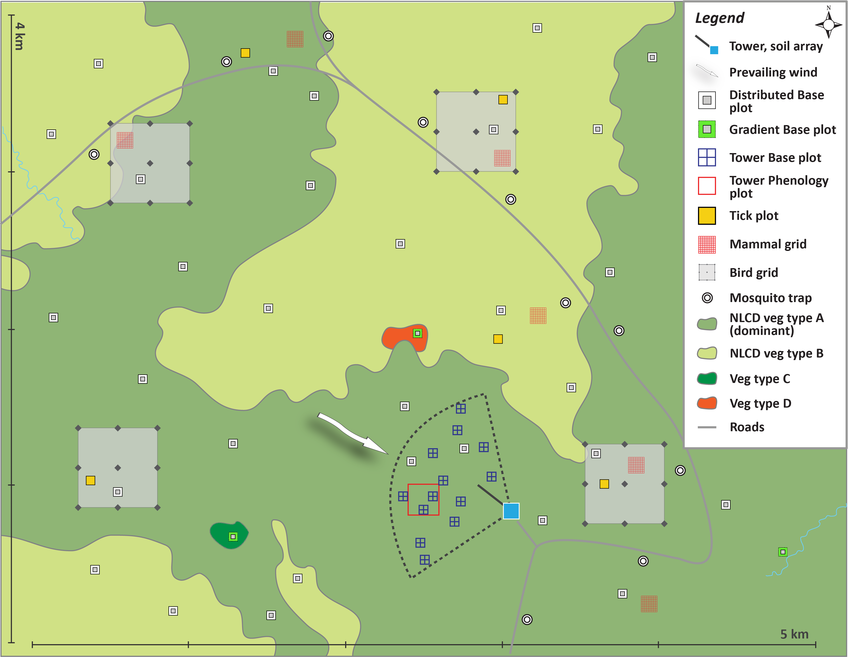

**Figure 1.** Generalized TOS sampling schematic, showing the placement of Distributed, Tower, and Gradient Plots.

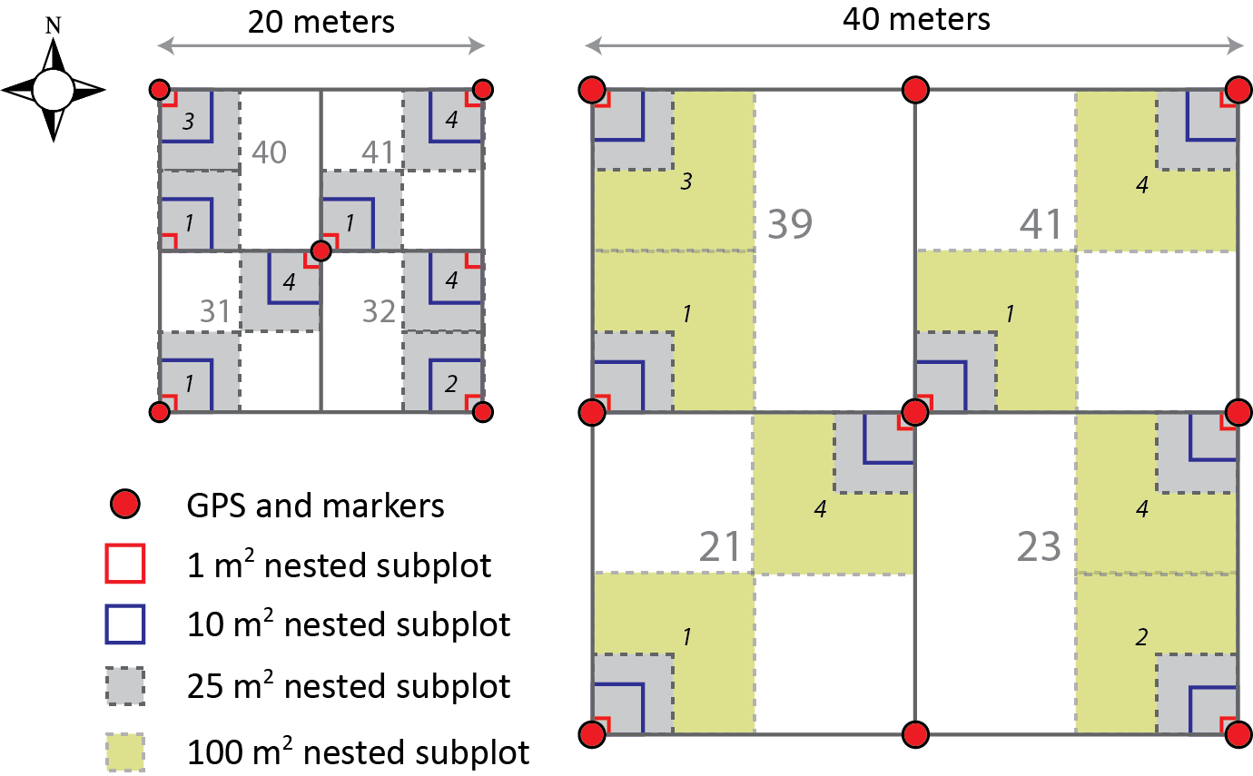

**Figure 2.** *(Left)* A 20m × 20m base plot, the larger destructive sampling portion of the plot is not shown); *(Right)* a 40m × 40m base plot, and associated nested subplots used for measuring woody stem vegetation. The 20m x 20m plot size may be used for either Distributed Plots or Tower Plots, and the 40m x 40m plot size is only for Tower Plots. Numbers in plain grey text indicate subplotIDs and numbers in italic black text indicate nested subplotIDs. The pointIDs associated with markers (red circles) are provided in Appendix G.

Standard Operating Procedures (SOPs) in Section 7 of this document provide detailed step-by-step directions, contingency plans, sampling tips, and best practices for implementing this sampling procedure. To properly collect data in the field, technicians **must** follow the protocol and associated SOPs. Use NEON’s problem reporting system to resolve any field issues associated with implementing this protocol.

The value of NEON data hinges on consistent implementation of this protocol across all NEON domains, for the life of the project. It is therefore essential that field personnel carry out this protocol as outlined in this document, and keep abreast of mid-season changes documented in NEON’s problem-tracking system. In the event that local conditions create uncertainty about carrying out these steps, it is critical that technicians document the problem and enter it into NEON’s problem tracking system.

Quality assurance will be performed on data collected via these procedures according to the NEON Science Performance QA/QC Plan (AD[07]).

# Sampling Schedule

## Sampling Frequency and Timing

*Frequency:* At each site, the sampling frequency for trees, saplings/shrubs, lianas, and ‘other’ growth forms depends on plot type:

* Distributed Plots: 1X per year, 3-year sampling interval
* Tower Plots: 1X per year, annual sampling interval
* See Appendix I for site-specific deviations from the above sampling intervals.

*Timing:* Estimated sampling windows, including estimated sampling onset and cessation dates, are provided on a per site basis in Appendix H. The dates in the appendix are multi-year averages derived from satellite data, and as such, individual future years will vary somewhat with respect to these dates. Once a sampling onset date has been selected for vegetation structure measurements at a given site by Field Operations, the onset of sampling in subsequent years should be consistent – i.e. within the same season and vegetation phenophase. Measurement of woody stemmed individuals (i.e. trees, shrubs, lianas) should ideally be coincident with measurement of species classified as ‘other’ (e.g., ferns, cacti), in order to enable a single sampling effort per year for vegetation structure work. This idealized sampling schedule means that, at a typical north temperate site, ferns will not be measured at peak greenness. However, for those fern species that senesce aboveground every year (e.g., Bracken Fern [*Pteridium aquilinum*]), individuals do need to be measured before senescent leaves and stems begin to break apart.

Additionally, ferns and ‘other’ growth forms do not need to be measured in Distributed Plots with forested NLCD class (Evergreen Forest, Deciduous Forest, and Mixed Forest), and do not need to be measured in non-forested Distributed Plots when they constitute < 50% of the total plot area as viewed by the Airborne Observation Platform (these are the same guidelines that trigger implementation of the Herbaceous Biomass clip harvest protocol in Distributed Plots).

## Criteria for Determining Onset and Cessation of Sampling

*Sampling onset:* The guiding principle is that vegetation structure measurements should begin after the majority of annual growth in a given growing season has completed. In many systems, the onset of sampling therefore coincides with the end-of-growing-season onset of the senescence phenophase for deciduous and herbaceous plants – i.e., the appearance of colored leaves / needles for trees and shrubs, and reduction in % green for herbaceous plants.

* For systems dominated by evergreen trees and shrubs, begin sampling when herbaceous plants begin to senesce.
* Approximately 50% of deciduous or herbaceous vegetation should have begun senescing before Vegetation Structure sampling begins.
* Use the dates in Appendix H as a guide for when to begin monitoring the vegetation for senescence, but bear in mind that the sampling start-date for individual years may deviate significantly from the average dates provided.
* At sites with pronounced wet/dry seasonality – e.g., D04 Guanica and D17 San Joaquin – structural measurements should begin once the dry season has begun and growth rates are minimal.
* At each site, the onset of sampling should be the same date for trees, saplings/shrubs, and lianas. That is, all growth forms should be measured at a given plot when that plot is sampled; technicians should **NOT** sample trees in all plots first, then re-sample plots for saplings/shrubs and lianas.

*Sampling cessation:* Measurement of woody stem vegetation structure must be completed within 4 months of sampling onset, AND before the onset of the next growing season – i.e., before new leaves expand.

### Sites with No Distinct Growing Season

For sites with no distinct growing season, sampling should begin at the same time every year ± 2 weeks. Once flux data are available at each site, Science can provide more precise sampling windows on a site-by-site basis.

## Timing for Laboratory Processing and Analysis

Not applicable.

## Sampling Timing Contingencies

When unexpected field conditions require deviations from this protocol, the guidance in **Table 2** must be followed to ensure that basic data quality standards are met:

**Table 2.** Contingency guidelines and possible outcome for data product quality.

| **Delay/Situation** | **Action** | **Outcome for Data Products** |
| --- | --- | --- |
| Hours to 4 weeks | If delay prevents completion of measuring/mapping a plot or sub-plot, use flagging to ensure it is clear which stems have been measured/mapped and resume data collection from the plot or subplot ASAP. | None for woody stem data; ferns may senesce in this time frame, leading to increased uncertainty for this growth form. |
| If delay occurs between plots or sub-plots, resume data collection from the next plot or sub-plot ASAP. | None for woody stem data; ferns may senesce in this time frame, leading to increased uncertainty for this growth form. |
| 4 or more weeks | If delay prevents completion of measuring/mapping a plot or sub-plot, use flagging to ensure it is clear which stems have been measured/mapped and resume data collection from the plot or sub-plot ASAP. | Increased error in aboveground biomass and NPP estimates. Temporary flagging may be lost, causing duplicate measurements of individuals; significant wood growth could occur in fast-growing species. |
| If delay occurs between plots or sub-plots, resume data collection from the next plot or sub-plot ASAP. | Increased error in aboveground biomass and NPP estimates. Significant wood growth could occur in fast-growing species. |

## Criteria for Permanent Reallocation of Sampling within a Site

Measurement of Vegetation Structure will occur on the schedule described above at up to 20 randomly selected Distributed Plots, and up to the total number of established Tower Plots per site. Ideally, sampling will occur at these locations for the lifetime of the Observatory (core sites) or the duration of the site’s affiliation with the NEON project (relocatable sites). However, circumstances may arise requiring that sampling within a site be shifted from one particular location to another. In general, sampling is considered to be compromised when sampling at a location becomes so limited that data quality is significantly reduced. If sampling at a given plot becomes compromised, a problem ticket should be submitted by Field Operations to Science.

There are two main pathways by which sampling can be compromised. Sampling locations can become inappropriately suited to answer meaningful biological questions (e.g., a terrestrial sampling plot becomes permanently flooded). Alternatively, sampling locations may be located in areas that are logistically impossible to sample on a schedule that that is biologically meaningful.

For measurement of Vegetation Structure, criteria for considering a plot compromised depend on plot type:

* Distributed Plots: Sampled every 3 y; if sampling cannot be completed for 2 consecutive bouts then the plot should be considered compromised.
* Tower Plots: Sampled annually; if sampling cannot be completed for any two bouts in 3 consecutive years, then the plot should be considered compromised.

# Safety

This document identifies procedure-specific safety hazards and associated safety requirements. It does not describe general safety practices or site-specific safety practices.

Personnel working at a NEON site must be compliant with safe field work practices as outlined in the Operations Field Safety and Security Plan (AD[02]) and EHS Safety Policy and Program Manual (AD[01]). The Field Operations Manager and Lead Field Technicians have primary authority to stop work activities based on unsafe field conditions; moreover, all employees have the responsibility and right to stop their work in unsafe conditions.

A laser rangefinder/hypsometer/compass instrument is used to map individual woody stems as points, and to measure various stem structural attributes. Safety considerations for this instrument include:

* Avoid staring directly at the laser beam for prolonged periods. The rangefinder is classified as eye-safe to Class 1 limits, which means that virtually no hazard is associated with directly viewing the laser output under normal conditions. However, as with any laser device, reasonable precautions should be taken during operation. It is recommended that you avoid staring into the transmit aperture while firing the laser.
* Never attempt to view the sun through the scope. Looking at the sun through the scope may permanently damage the eyes.

Additional safety issues associated with this field procedure include potential exposure to poisonous *Toxicodendron* oils. Protocol-specific equipment to mitigate exposure is listed in Section 6 (**Table 6**), and additional general mitigation strategies are discussed in the Toxicodendron SOP (RD[12]).

# Personnel and Equipment

A minimum team size of two field technicians is required for measuring and mapping woody stems, and identifying to species.

## Equipment

The following equipment is needed to implement the procedures in this document. Equipment lists are organized by task. They do not include standard field and laboratory supplies such as charging stations, first aid kits, drying ovens, ultra-low refrigerators, etc.

**Table 3.** Equipment list – Preparing for sampling (SOP A).

| **Item No.** | **R/S** | **Description** | **Purpose** | **Quantity** | **Special Handling** |
| --- | --- | --- | --- | --- | --- |
| **Durable Items** | | | | | |
| MX100703 | R | GPS receiver, recreational accuracy | Pre-load sampling locations | 1 | N |
| MX100322 | R | Laser Rangefinder, ± 30 cm accuracy | Map stems; measure stem height and crown diameters. Mapping; measuring stems > 2 m height | 1 | N |
|  | R | Hammer | Label blank tags | 1 | N |
| MX103480 | R | Hand stamp steel die set | Label blank tags | 1 set | N |
| **Consumable items** | | | | | |
| MX103942 | R | All weather copy paper | Print datasheets | As needed | N |
| MX103481 | R | Round unnumbered aluminum tag, silver | Pre-label for tagging multi-stemmed individuals. | 50 | N |

R/S=Required/Suggested

**Table 4.** Equipment list – Mapping and tagging (SOP B).

| **Item No.** | **R/S** | **Description** | **Purpose** | **Quantity\*** | **Special Handling** |
| --- | --- | --- | --- | --- | --- |
| **Durable Items** | | | | | |
| MX103214 | S | Cardboard ventilator | Press collected individuals for identification |  | N |
| MX104361 | R | Chaining pins or other suitable anchor | Anchor measuring tapes | 4 | N |
| MX100320 | S | Compass with mirror and declination adjustment | Determine nested subplot boundary | 1 | N |
|  | S | Cooler | Chill perishable samples in field | 1 | N |
| MX106349 | R | Diameter tape, 200 cm | Measure stem diameter. Stems present with diameter > 64 cm | 1 | N |
| MX106348 | R | Diameter tape, 64 cm | Measure stem diameter. Stems present with 5 cm < diameter < 64 cm | 1 | N |
|  | S | Field guide, regional flora reference guide and/or key | Identify unknown species | 1 | N |
| MX103218 | R | Foliage filter | Allow laser rangefinder use in dense vegetation | 1 | N |
| MX100703 | S | GPS receiver, recreational accuracy | Navigate to sampling location | 1 | N |
|  | S | Site map | Navigate to sampling location | 1 | N |
|  | R | Hammer | Nail tags to trees, label blank tags | 1 | N |
| MX103480 | R | Hand stamp steel die set | Label blank tags | 1 set | N |
|  | R | Handheld caliper, 0.1 cm precision | Measure stem diameter < 5 cm; lianas prevent accurate diameter measurement with tape | 1 | N |
| MX100358 | S | Ice pack | Chill perishable samples in field | As needed | N |
| MX100322 | R | Laser Rangefinder, ± 30 cm accuracy | Determine nested subplot boundary; map stems; measure stem height and crown diameter. Individuals with relatively large canopies; plots with slopes > 20% | 1 | N |
| MX104369 | R | Measuring tape, minimum 50 m | Determine nested subplot, subplot boundary | 4 | N |
| MX100312 | S | Paper blotters | Press collected individuals for identification | As needed | N |
| MX100316 | S | Plant press | Press collected individuals for identification | As needed | N |
| MX104381 | S | Tripod , non-magnetic | Hold laser rangefinder directly over plot marker | 1 | N |
| MX104359 | R | White reflector or reflective tape | Reflective target for laser rangefinder; aids in measuring distance to target accurately | 1 | N |
|  | R | Wire cutter | Cut wire to desired length | 1 | N |
|  | S | PVC pipe, 1.4 m length, max 1” diameter, marking at 1.3 m | Quickly find measurementHeight and tag height for straight boles | 1 | N |
|  | S | PVC pipe, 0.1 m length, max 1” diameter | Quickly find measurementHeight for ddh | 1 | N |
| **Consumable items** | | | | | |
|  | R | AA battery | Spare battery for GPS receiver | 4 | N |
| MX103224 | R | Aluminum nail | Affix tag to stems with DBH ≥ 5 cm | As needed | N |
| MX107336 | R | Aluminum wire, 20 gauge | Affix tag to stems with DBH ≥ 5 cm | As needed | N |
|  | R | CR123A battery | Spare battery for laser rangefinder | 2 | N |
| MX103940 | S | Flagging tape | Temporarily mark stems after measurement | 2 | N |
| MX104546 | R | Fluorescent lumber crayon | Mark DBH measurement location on stem | 1 | N |
| MX100592 | S | Resealable plastic bag, 1 gal | Collect voucher specimens | 20 | N |
| MX103478 | R | Round numbered aluminum tag, silver; 0001-6000 and 8001-9999 | Tag qualifying stems | As needed | N |
| MX103481 | R | Round unnumbered aluminum tag, silver | Tag multi-stemmed individuals. | 50 | N |
|  | S | Survey marking flag, PVC or fiberglass stake | Delineate sampling area | 12 | N |
|  | S | Tabloid newspaper pages | Press collected individuals for identification |  | N |
| **Resources** | | | | | |
|  | R | Field datasheet | Record data |  | N |

R/S=Required/Suggested

**Table 5.** Equipment list – Biomass/productivity measurements* (SOP C).

| **Item No.** | **R/S** | **Description** | **Purpose** | **Quantity\*** | **Special Handling** |
| --- | --- | --- | --- | --- | --- |
| **Durable Items** | | | | | |
| MX103214 | S | Cardboard ventilator | Press collected individuals for identification |  |  |
| MX104361 | R | Chaining pins or other suitable anchor | Anchor measuring tapes | 4 | N |
|  | S | Cooler | Chill perishable samples in field | 1 | N |
| MX106349 | R | DBH tape, 200 cm | Measure stem diameter. Stems present with diameter > 64 cm | 1 | N |
| MX106348 | R | DBH tape, 64 cm | Measure stem diameter. Stems present with 5 cm < diameter < 64 cm | 1 | N |
|  | R | Haglof Mantax Black calipers, 95 cm | Measure stem diameters up to 95 cm when lianas are attached and a DBH tape will not work. | 1 | N |
|  | R | Haglof Mantax Black calipers, 50 cm | Measure stem diameters up to 50 cm when lianas are attached and a DBH tape will not work. | 1 | N |
|  | S | Field guide, regional flora reference guide and/or key | Identify unknown species | 1 | N |
| MX103218 | R | Foliage filter | Allow laser rangefinder use in dense vegetation | 1 | N |
| MX100703 | S | GPS receiver, recreational accuracy | Navigate to sampling location | 1 | N |
|  | S | Site map | Navigate to sampling location | 1 | N |
|  | R | Hammer | Nail tags to trees, label blank tags | 1 | N |
| MX103480 | R | Hand stamp steel die set | Label blank tags for multi-stem trees | 1 set | N |
|  | R | Handheld caliper, 0.1 cm precision | Measure stem diameters < 5 cm | 1 | N |
| MX100358 | S | Ice pack | Chill perishable samples in field | As needed | N |
| MX100322 | R | Laser Rangefinder, ± 30 cm accuracy | Map stems recruited into the minimum size class; measure stem height, crown diameter. Brushy; trees with relatively large canopy diameters; slopes ≥ 20% | 1 | N |
| MX105823 | R | Measuring stick, 2 m folding | Measure heights of small-stature woody vegetation | 1 | N |
|  | S | Aluminum or fiberglass measuring rod, 5 m telescoping | Measure heights of medium-stature woody vegetation, measure crown dimensions for some shrubs | 1 | N |
| MX104369 | R | Measuring tape, minimum 50 m | Determine nested subplot, subplot boundary | 4 | N |
| MX100312 | S | Paper blotters | Press collected individuals for identification | As needed | N |
| MX100316 | S | Plant press | Press collected individuals for identification | 1 | N |
| MX104359 | R | White reflector or reflective tape | Reflective target for laser rangefinder; aids in measuring distance to target accurately | 1 | N |
|  | R | Wire cutter | Cut wire to desired length. Stems present with DBH < 5 cm | 1 | N |
| MX100320 | R | Compass with mirror and declination adjustment | Delineate nested subplots if markers are removed or disturbed | 1 | N |
|  | S | PVC pipe, 1.4 m length, max 1” diameter, marking at 1.3 m | Quickly find measurementHeight and tag height for straight boles | 1 | N |
|  | S | PVC pipe, 0.1 m length, max 1” diameter | Quickly find measurementHeight for ddh | 1 | N |
|  | S | Retractable metal measuring tape, 25 mm W x 10 m L, metric demarcations | Quickly measure mid-stature shrub crown dimensions | 1 | N |
| **Consumable items** | | | | | |
|  | S | AA battery | Spare battery for GPS receiver |  | N |
| MX103224 | R | Aluminum nail | Affix tag to stems with DBH ≥ 5 cm | As needed | N |
| MX107336 | R | Aluminum wire, 20 gauge | Affix tag to stems with DBH ≥ 5 cm | As needed | N |
|  | R | CR123A battery | Spare battery for laser rangefinder | 2 | N |
| MX103940 | S | Flagging tape | Temporarily mark stems after measurement | 2 | N |
| MX104546 | R | Fluorescent lumber crayon | Mark DBH measurement location on stem | 1 | N |
|  | S | Graph paper | Estimate area of shrub groups | As needed | N |
| MX103478 MX103477 MX103479 MX108192 MX108193 MX108194 MX108197 MX108198 | R | Round numbered aluminum tag, silver; 0001-6000 and 8001-9999 | Tag new qualifying stems | As needed | N |
| MX103481 | R | Round unnumbered aluminum tag, silver | Tag new multi-stemmed individuals | 50 | N |
|  | S | Survey marking flag, PVC or fiberglass stake | Delineate sampling area | 12 | N |
|  | S | Newspaper pages, tabloid size | Press collected individuals for identification | As needed | N |
|  | S | Cordless Power drill, 18V Li-ion | Pre-drill nail holes into trees with dense wood; prevent bending of aluminum nails | 1 | N |
| **Resources** | | | | | |
|  | R | Field datasheet | Record data |  | N |
|  | R | ‘Plot Metadata’ datasheets | Record data | As needed | N |

* Note that much of this equipment will only be used if tags must be replaced or individuals graduate in to minimum class size.  
R/S=Required/Suggested

**Table 6.** Equipment and materials required for a team of two to minimize exposure to toxic oils from *Toxicodendron spp.*

| **Item No.** | **R/S** | **Description** | **Purpose** | **Quantity\*** | **Special Handling** | |
| --- | --- | --- | --- | --- | --- | --- |
| **Durable Items** | | | | | |
|  | S | Haglof Mantax Black calipers, 95 cm | Measure stem diameters up to 95 cm when lianas are attached; label for use with *Toxicodendron* to minimize spread of oils. Accurate enough to also measure *Toxicodendron* diameter. | 1 | N | |
|  | S | Haglof Mantax Black calipers, 50 cm | Measure supporting stem diameters up to 50 cm when lianas are attached; label for use with *Toxicodendron* spp. to minimize spread of oils to other equipment. | 1 | N | |
|  | R | Handheld caliper, 0.1 cm precision | Label for use with *Toxicodendron* spp. to minimize spread of oils to other equipment | 1 | N | |
|  | R | Pruning shear | Label for use with *Toxicodendron* spp. to minimize spread of oils to other equipment. Used to gain access to woody stems surrounded by *Toxicodendron*. | 1 | N | |
| **Consumable items** | | | | | |
| MX107108 | R | Cleanser, urushiol-specific, Tecnu or equivalent | Clean equipment after use with *Toxicodendron* spp. | 1 | N | |
|  | R | Nitrile or cotton gloves | Prevent oil contact with skin | Box of 12 | N | |
|  | R | PPE outer-wear | Prevent oil contact with skin, normal clothing | One set per person | N | |
|  | R | Trash bag | Dispose of used gloves and PPE to minimize toxic oil transfer | As needed | N | |

R/S=Required/Suggested

## Training Requirements

All technicians must complete required safety training and protocol-specific training for safety and implementation of this protocol as required in the Field Operations Job Instruction Training Plan (AD[05]).

Technicians must be trained in the proper care of the laser rangefinder. Although this tool is resistant to dust and water, it is important to seal open ports and use lens caps when applicable. Care must also be taken to avoid scratching lenses.

Finally, technicians should be trained to carefully measure the heights of trees using the laser rangefinder/hypsometer.

## Specialized Skills

At least one of the technicians executing this protocol must be able to identify woody plants to species via visual inspection and use of a dichotomous/polyclave key.

## Estimated Time

The time required to implement a protocol will vary depending on a number of factors, such as stem density, skill level, species diversity, environmental conditions, and distance between plots. The timeframe provided below is a per plot estimate for a skilled two-person team (i.e., not the time it takes at the beginning of the field season). Use this estimate as framework for assessing progress. If a task is taking significantly longer than the estimated time, a problem ticket should be submitted. Please note that if sampling at particular locations requires significantly more time than expected, Science may propose to move these sampling locations.

An experienced two-person team may complete mapping and tagging of woody stems in 6-12 hours per plot. Annual measurement of large stems and other woody vegetation components within a forested 40 m x 40 m Tower plot may require up to 8-10 hours to complete. Actual time requirements to complete vegetation structure measurements will vary greatly between sites, and depends on the variety of growth forms present and the stem density within plots.

# Standard Operating Procedures

The tasks associated with collecting vegetation structure measurements are broken up here into a series of separate SOPs.

**SOP A: Preparing for Sampling.** Tasks completed in the Domain lab, in preparation for the field campaign. Contains steps for loading plot data onto the GPS unit and calibrating the laser rangefinder.

**SOP B: Classification, Mapping, and Tagging.** Provides the following:

* Guidelines for classifying woody vegetation based on structural attributes and taxonID.
* Guidelines for using nested subplots to standardize sampling effort across plots.
* Instructions for mapping individuals relative to plot markers, and details for how to tag mapped trees, shrubs and lianas.
* Instructions for assigning appropriate taxonIDs to woody vegetation.

**SOP C: Measuring Vegetation Structure in the Field.** Contains detailed procedures for measuring:

* Apparent Individuals
* Shrub Groups
* ‘Other’ growth forms

**SOP D: Field Campaign Follow-up.** Necessary steps following successful completion of field work.

**SOP E: Data Entry and Verification.** Guidelines and requirements for successful data entry. This SOP is NOT a substitute for TOS Protocol and Procedure: Manual Data Transcription (RD[04]). Technicians must read RD[04] prior to transcription from paper data sheets.

###### Preparing for Sampling

Preparing for Data Capture

Mobile applications are the preferred mechanism for data entry. Mobile devices should be fully charged at the beginning of each field day, whenever possible.

However, given the potential for mobile devices to fail under field conditions, it is imperative that paper data sheets are always available to record data. Paper data sheets should be carried along with the mobile devices to sampling locations at all times.

Office tasks

1. Transfer all required files containing plot marker locations to the recreational accuracy handheld GPS receiver.
2. Use the hand stamp and die set to pre-label blank aluminum tags with ‘A’, ‘B’, ‘C’, etc. for tagging multi-bole trees (‘mbt’, if present at site).

Checking the laser rangefinder

Detailed instructions for setting declination, calibrating the tilt-sensor, and calibrating the compass are found in TOS Standard Operating Procedure: Laser Rangefinder Use and Calibration (RD[09]).

1. Make sure the lenses on the laser rangefinder are free of dirt and debris, and clean with a lens cloth or lens tissue if necessary.
2. Declination changes with time at each site, and should be looked up annually using the NOAA Magnetic Field Calculator (<http://www.ngdc.noaa.gov/geomag-web/>)
3. *TruPulse Declination Offset.* Check the current declination against what is entered in the TruPulse.
4. *TruPulse Tilt-sensor Calibration.* In the rare instance that the TruPulse has suffered a severe drop shock, the tilt-sensor requires re-calibration prior to continued field work.
5. *Compass Calibration.* The compass should be calibrated after the batteries are changed. Be aware that interference from indoor magnetic fields can prevent accurate calibration, and can cause the calibration routine to fail. If this is the case, calibrate in the field.

Data sheet preparation

To enable accurate and expeditious field measurement of previously measured apparent individuals, it is helpful to generate per plot lists of tagIDs, and other key identifying data, for all individuals measured within the plot the previous year. The mobile data ingest platform will store previously created records for up to 3 years, and creating per plot lists of previously measured tagIDs entails copying these data and printing them out in order efficiently to track work progress in the field.

1. The fields below should be pre-populated by copying previously collected data into the ‘Apparent Individuals’ data sheet.

* **tagID**
* **subplotID**
* **nestedSubplotID**
* **taxonID**
* **measurementHeight**
* **growthForm**, useful for finding an individual. Be advised the value may change from year to year, and changed growthForm values may require different data to be collected from an individual in the current year.
* **plantStatus**
* **shape** (shrubs only)

1. [Optional] Use mapping data to create maps of each plot, to enable finding previously measured individuals within a spatially explicit framework.

* An R script, developed by Field Operations, is available for creating maps of plots.

###### Classification, Mapping, and Tagging

Classifying, mapping, and tagging woody vegetation is important because it allows repeat measurements to be made on identified individuals. Once species and growth form are known, it is possible to estimate biomass via appropriately chosen allometric equations.

Classifying, mapping, and tagging qualifying woody individuals occurs in both Distributed and Tower Plots, and may occur in Gradient Plots if this latter plot type is established at a given site.

* In 20m x 20m Distributed, Gradient, and Tower Plots, the entire plot is assessed for qualifying individuals.
* In 40m x 40m Tower Plots, two randomly selected 20m x 20m subplots are assessed for qualifying individuals.
  + Lists of randomly selected subplots are provided by Science.
  + No mapping or measurements ***of any growth form*** will take place in those 20m x 20m subplots that are **NOT** selected.

Classifying Woody Vegetation to Growth Form

Woody vegetation is classified to growth form using stem diameter (DBH or ddh), height, and site-specific knowledge of the species in question (**Table 7**, **Figure 3**, **Figure 4**). Note that individuals may change classification from one year to the next, due to normal growth or damage (i.e., loss of boles or stems). Additional ‘other’ growth forms are listed in Appendix F. The distinction between “apparent individuals” and “groups” is also used when classifying vegetation. In general small trees and shrubs can exist either:

* As isolated ‘Apparent Individuals,’ with either single stems or multiple connected stems; or
* As groups of individuals in contact with each other such that apparent individuals cannot be discerned, and crowns blend together into a continuous canopy (e.g. a shrub or vine thicket). Such groups are hereafter referred to as ‘Shrub Groups’.

The ‘Apparent Individual’ designation is always preferable to that of ‘Shrub Group’ due to the fact that allometric equations used for estimating shrub biomass typically depend on basal stem diameter or DBH measurements, and these measurements are not made for shrub groups. Shrub group measurements allow only for estimation of shrub volume, and translating volume to biomass is often not possible. Nonetheless, the shrub group designation is warranted when vegetation forms dense, impenetrable, or thorny thickets that could not be measured without damage to the vegetation itself, or that may cause injury to staff.

**Table 7**. Growth forms into which woody vegetation is classified, and their definitions. Parentheses following the terms in the list below indicate the 3-letter code used for classifying particular defined growth forms.

| **Growth Form** | **Definition** |
| --- | --- |
| liana (**lia**) | Non-self-supporting woody stems with DBH ≥ 1 cm. ‘ddh’ is not measured for lianas. |
| single-bole tree (**sbt**) | A self-supporting individual with a single bole ≥ 10 cm diameter at breast height. Usually greater than 4 – 5 meters height. |
| multi-bole tree (**mbt**) | A self-supporting individual with multiple boles at breast height. At least one bole must have DBH ≥ 10 cm, and individual is usually greater than 4 – 5 meters height. To qualify as an additional bole, the fork in question must meet the following criteria:   * Be at least ⅓ the diameter of the main bole. * The angle formed with the pith of the main bole must be 45˚ or less. * The pith must intersect the pith of the main bole at or below 130 cm above the ground. * Multiple boles may also emerge independently from the ground, provided they are connected belowground. |
| small tree (**smt**) | Typically a self-supporting individual with the potential to grow into either a single-bole tree or a multi-bole tree; also includes tree species that, at maturity, never attain the stature of single-bole or multi-bole trees (e.g., *Acer pensylvanicum* or *Picea mariana* under some environmental conditions). Diameter at breast height for one or more stems meets the criteria 1 cm ≤ DBH < 10 cm, and usually does not exceed 4 – 5 meters height. |
| sapling (**sap**) | A small, self-supporting individual with the potential to grow into either a single-bole tree or a multi-bole tree. DBH is < 1 cm, or total height is < 130 cm, and ddh of at least one stem is ≥ 1 cm. |
| single shrub (**sis**) | A self-supporting individual, often with multiple qualifying boles. Diameter of at least one bole at breast height meets the criteria 1 cm ≤ DBH < 10 cm. Usually does not exceed 4 – 5 meters maximum height at maturity. Uncommonly, DBH can be ≥ 10 cm; when assigning this growthForm, consider the USDA classification and the maximum height potential of the species (see *Rhododendron* example below). |
| small shrub (**sms**) | A self-supporting individual, typically with multiple qualifying stems; includes typical ‘subshrub’ species that may never exceed 130 cm height, as well as individuals that will mature into ‘sis’ growth form. The ddh is ≥ 1 cm for at least one emergent stem. Individuals that have no stems with ddh ≥ 1 cm are not measured with this protocol, and will be measured as part of the herbaceous plant sampling effort. |
| shrub group | * Shrub Groups are defined as two or more individuals in contact, such that it is impossible to discern “individuals.” The word “individual” here refers to “apparent” individuals, not “genetic” individuals (e.g., members of an Aspen clone). * Shrub Groups may contain multiple species (including vine masses), and both live and dead material from one or more species. * Shrub Groups that are primarily ‘sms’ individuals should on average have stems with ddh ≥ 1 cm; measure a subset of stems to make this determination, NOT every stem. If the majority of stems in the Shrub Group have ddh < 1 cm, do not measure. |

*Example*: A *Quercus alba* individual in the eastern U.S. may be classified as either a sapling (sap), a small tree (smt), a single-bole tree (sbt), or a multi-bole tree (mbt), depending on life stage and the specific growth habit of the individual. However, a small *Q. alba* individual would not be classified as a small shrub (sms) or single shrub (sis) because this species is broadly recognized as a tree species (e.g., USDA PLANTS), and the biomass of large and small individuals can be estimated using general allometric equations developed for trees (e.g., Jenkins et al. 2003, Jenkins et al. 2004).

*Example*: An *Acer rubrum* individual has four boles with the following diameters at 130 cm along each bole: 12 cm, 9 cm, 4 cm, and 3.5 cm. This individual is classified as a multi-bole tree growth form because the largest bole is ≥ 10 cm DBH, and there are two secondary boles with diameters ≥ ⅓ the diameter of the largest bole. The smallest bole with DBH = 3.5 cm is not tagged and measured because its diameter is not ⅓ that of the largest bole.

*Example:* Species information may not be informative with respect to assigning growth form. For example, *Toxicodendron* spp. commonly exist as lianas, small shrubs, and shrub groups.

Below, **Figure 3** provides high-level classification information, and **Figure 4** indicates how structural data inform classification to growth form. However, as indicated above, **Figure 4** must be used in combination with the definitions in **Table 7**, and with knowledge of a given species, to make a correct classification.

*Example:* *Rhododendron* *spp.* may grow large enough that one or more stems have DBH ≥ 10 cm. If only DBH and stem count are considered, **Figure 4** on its own would have large *Rhododendron* individuals classified either as a single-bole tree (multiple stems, but DBH of only one bole ≥ 10 cm) or a multi-bole tree (more than one bole with DBH ≥ 10 cm). However, considering *Rhododendron spp.* are usually < 4 – 5 meters height, these large individuals are classified as single shrub (sis).

*Example:* A young Interior Live Oak (*Quercus wislizenii*) may split below 130 cm into multiple boles with 10 cm > DBH ≥ 1 cm. Because this species routinely achieves single- and multi-bole tree status, smaller individuals are classified as ‘small tree’, rather than ‘single shrub’ (see dashed arrow in **Figure 4**).

*Example:* A Big Sagebrush individual (*Artemisia tridentata*) has multiple emergent boles / stems, with only one such emergent stem having 10 cm > DBH ≥ 1 cm; all others have DBH < 1 cm or are < 130 cm height. This species never attains single- or multi-bole tree status, and this individual is classified as a ‘single shrub,’ rather than a ‘small tree.’

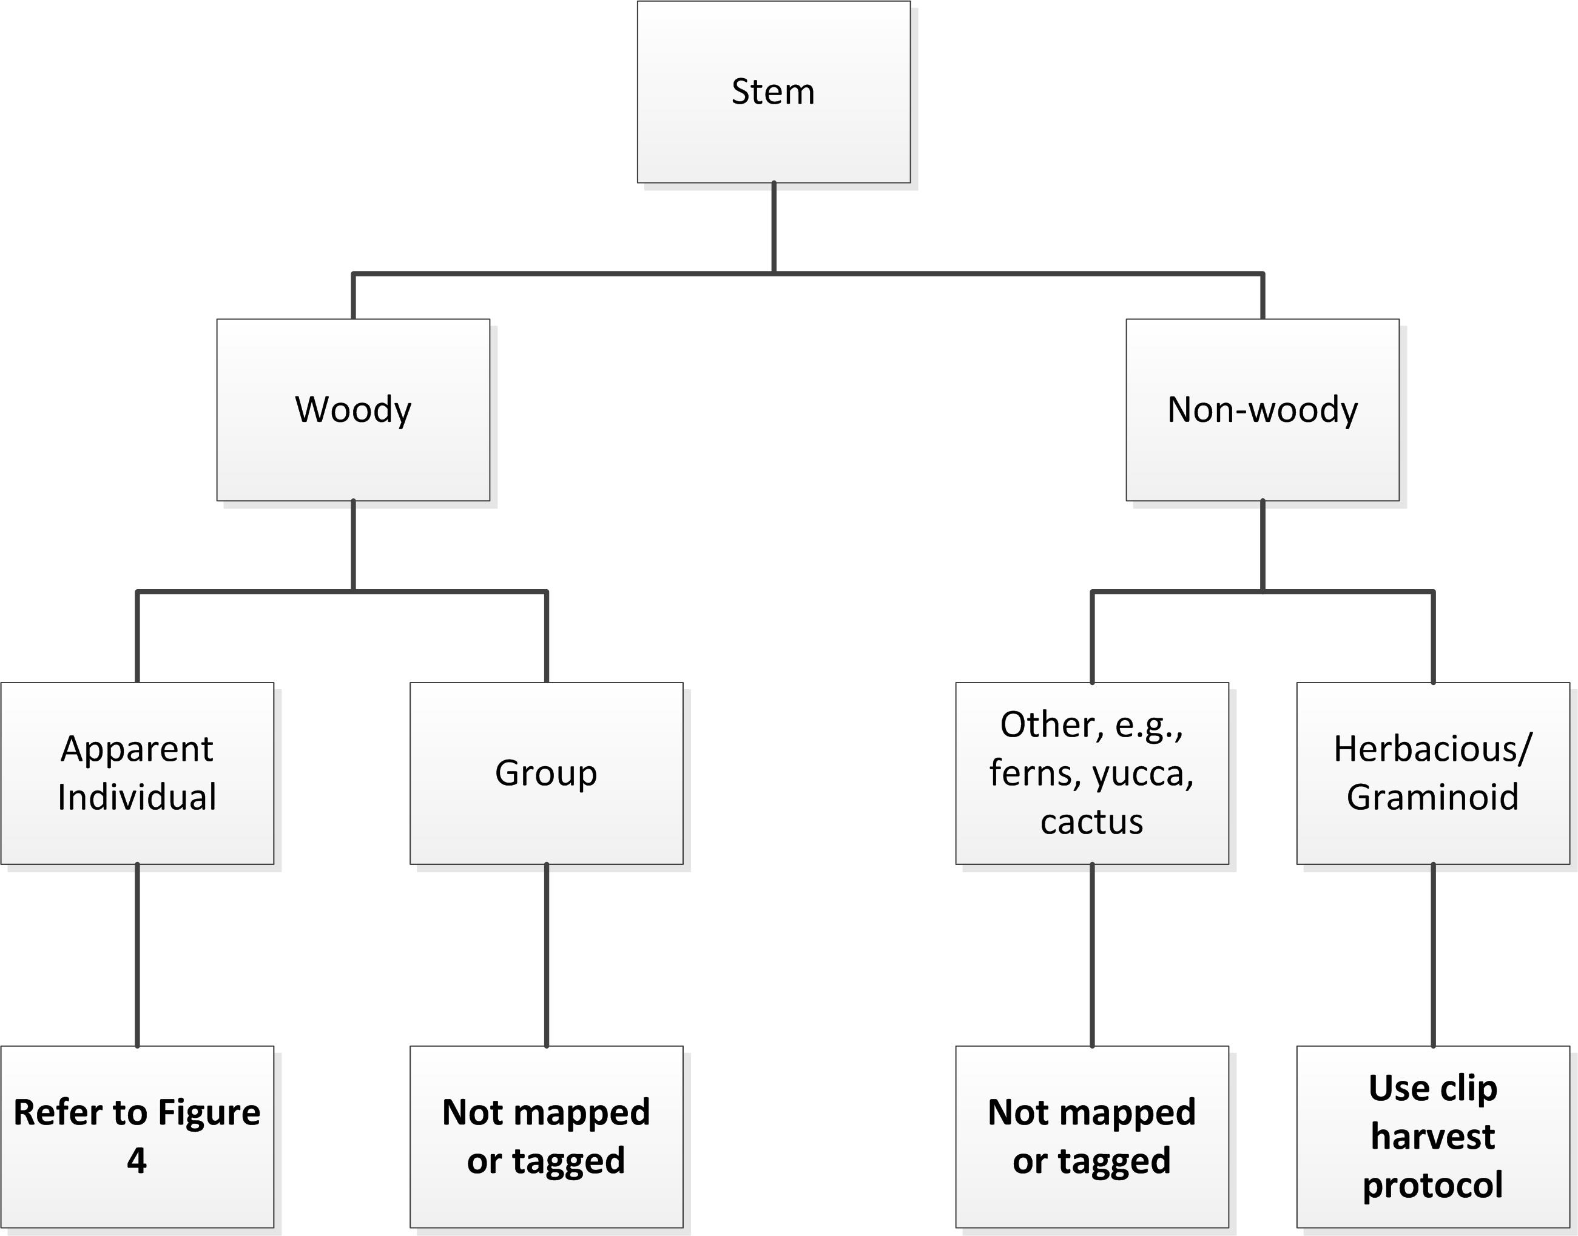

**Figure 3**. High-level classification tree for assigning vegetation to growth form, and assigning the correct protocol.

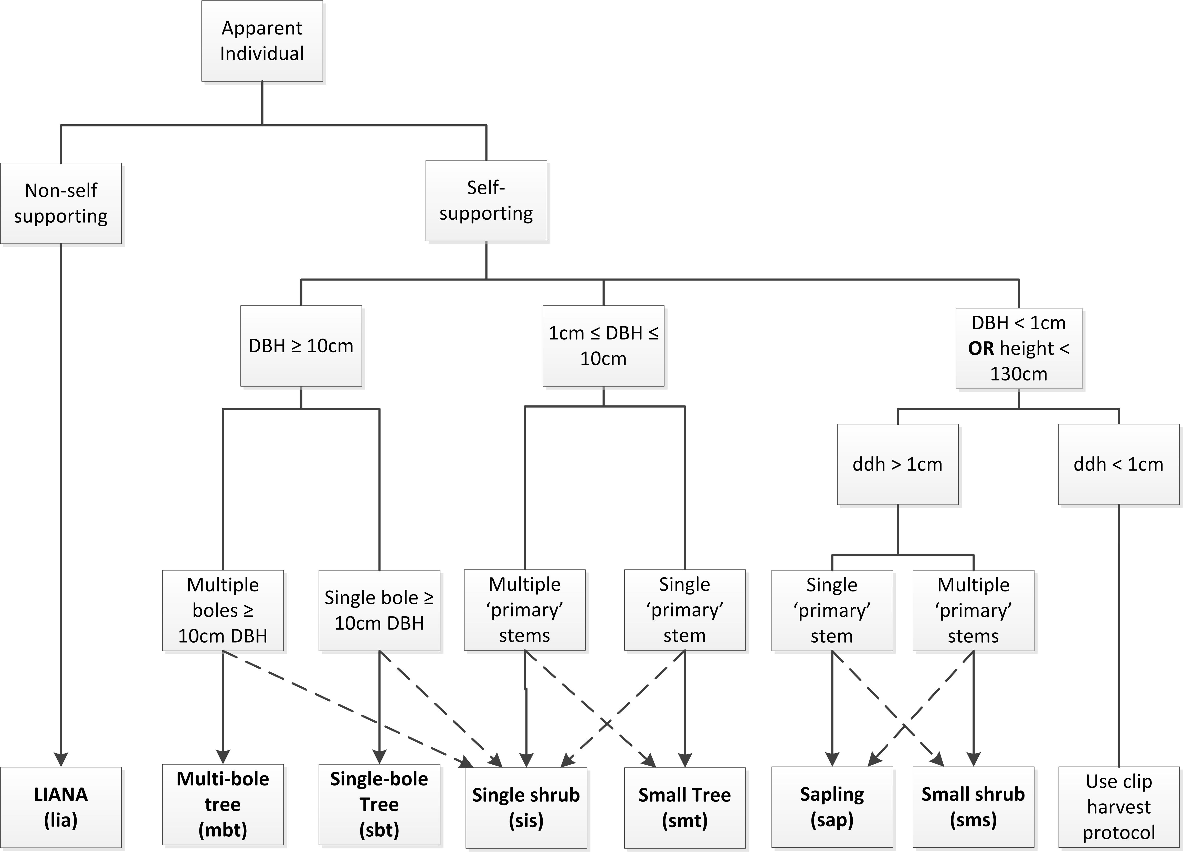

**Figure 4**. Decision tree indicating how structural observations and stem diameter data inform the classification of apparent individuals to growth form. Dashed lines call out points where growth form classification may change after considering height and species-specific information.

Important

This section provides generalized definitions and guidance for determining growth forms. However, not every possible situation can be addressed in this generalized format. For example, the line between a multi-bole apparent individual and a shrub group can be difficult to clearly define, especially for clonal species. Following this protocol may lead technicians in different domains to different conclusions. Therefore, we recommend creating site-specific or species-specific materials within each Domain to maintain consistency through time with respect to how decisions are made to resolve common problem situations. Science will review documents and facilitate sharing between Domains.

Using nested subplots to standardize the sampling effort

Because saplings, small trees, shrubs, lianas, and many other woody and non-woody species sampled via this protocol can attain very high stem densities, it may be necessary to employ a nested subplot approach in order to standardize the sampling effort across plots. Subplot and nested subplot sizes are shown in **Figure 2**. To ensure consistency:

* On a per plot basis, nested subplot size may be chosen independently for:
  + Lianas,
  + The sum of ‘smt + sis + sap + sms + shrub groups’; and
  + Any ‘other’ qualifying vegetation, including palms, agave, yucca, ferns, etc. (see Appendix F for a full list of ‘other’ qualifying vegetation).
* ***For all growth forms, the chosen nested subplot size must be used for the entire plot, and the same size nested subplots within a plot are typically used from year to year***.

Subplot and nested subplot details are illustrated in **Figure 2**, and compiled below in **Table 8**. Nested subplots are numbered in sequence beginning with the SW corner of the subplot; SW=1, SE=2, NW=3 NE=4 (**Figure 2**).

**Table 8**. List of supported subplot and nested subplot dimensions that vary with plot size. The decision to use nested subplots is made on a per plot basis, and allows standardization of sampling effort across plots.

| **Plot Size** | **Plot component** | **Dimensions (area)** | **Additional Information** |
| --- | --- | --- | --- |
| 20m x 20m (400 m2) | subplot | 10m x 10m (100 m2) | These subplots are used to organize the layout of nested subplots, and are not otherwise used for sampling. |
| nested subplot | 5m x 5m (25 m2) | Nested subplots not employed for trees with DBH ≥ 10 cm; these individuals are measured throughout the entire plot. |
| 3.1 m x 3.16m (10 m2) |
| 1m x 1m (1 m2) |
| 40m x 40m (1600 m2) | subplot | 20m x 20m (400 m2) | Two of the four subplots are randomly selected for sampling by Science. Lists of random subplots are provided on the NEON intranet. |
| nested subplot | 10m x 10m (100 m2) | Nested subplots are not employed for trees with DBH ≥ 10 cm; ‘sbt’ and ‘mbt’ individuals are measured wherever they occur in the randomly selected subplots. |
| 5m x 5m (25 m2) |
| 3.16m x 3.16m (10 m2) |
| 1m x 1m (1 m2) |

Selecting the optimal measurement area

In the first year of sampling, the nestedSubplotArea is selected once per plot, for each of the growth forms (or groups of growth forms) listed above in SOP B.2. The following guidelines apply when determining whether nested subplots can be employed:

* Visually assess the density of qualifying, apparent individuals across the whole plot for each of the three groups listed above, and estimate a nested subplot size appropriate for each group.
* A shrub group that receives a single ID is counted as 1 individual for the purpose of selecting an appropriate nested subplot size. Should a single, large shrub group span more than one nested subplot area, tally the group within each of the nested subplots in which it occurs.

Plots are assessed annually for stem density on a per growthForm basis. Changes to nested subplot sizes may only be made in consultation with NEON Science following significant changes in stem density that are anticipated to be long-term in nature (e.g., increase or decrease in stems following fire, blow-down, logging, woody stem encroachment, etc.).

The ‘Plot Metadata’ ingest table ensures an accurate, detailed per plot per year report of growthForm presence / absence at the scale of the plot or subplot, and nested subplot, such that the total area sampled is clearly documented, which is critical for scaling purposes. In addition, the ‘Plot Metadata’ table transparently indicates the completeness of the planned sampling effort to the NEON end-user community.

***Steps to determine nested subplot size in a given plot:***

1. Assess the plot or subplots for the presence of qualifying vegetation (listed in **Table 7** and Appendix F).

* For the entire plot, record ‘Y’ or ‘N’ for each of the growthForms below in the **targetTaxaPresent** field of the ‘Plot Metadata’ ingest table (RD[05]):
  + Trees (sbt, mbt)
  + Small trees, saplings, single shrubs, small shrubs, and shrub groups (smt, sap, sis, sms + shrub groups)
  + Lianas
  + Cacti
  + Ferns
  + Yucca
  + Agave
  + Palms
  + Ocotillo
  + Xerophyllum (Bear Grass)
* If there is no qualifying vegetation and ‘targetTaxaPresent = N’ for all growth forms, continue to the next plot.

1. If a plot HAS been measured previously, use the **same nested subplot size each year** in order to ensure that repeat measurements are made on tagged stems.

* Check the ‘Plot Metadata’ data sheet which summarizes measurement area for all plots before selecting a new measurement area for a given plot.
* In a given plot, if significant changes in stem density have occurred over time, due to succession, self-thinning, natural disturbance, or management activities, discuss with Science whether a change in nested subplot implementation is warranted.
  + Be aware that changes in nested subplot size may result in additional mapping and tagging work.

1. For plots that have NOT been measured previously, or that have experienced significant changes in stem density, assess vegetation density and select an optimal measurement area. The appropriate density depends on plot size:

**In a 20m x 20m Distributed Plot or Tower Plot:**

* Goal: Sample a minimum of 20 individuals across the entire 20m x 20m plot

FOR INDIVIDUALS DISTRIBUTED RELATIVELY HOMOGENEOUSLY, THIS IS EQUIVALENT TO:

* 5 apparent individuals per 100 m2 subplot

OR

* Approximately 2-3 apparent individuals per nested subplot

*Note: If nested subplots are employed, there must be a* ***minimum*** *of 20 individuals sampled across the entire plot (****see scenario in Box 1****). If fewer than 20 individuals are present within the plot, or within any available nested subplot size, sample the entire plot.*

**In a 40m x 40m Tower Plot:**

* Goal: Sample a minimum of 20 apparent individuals ***for at least one*** 20m x 20m subplot

FOR INDIVIDUALS DISTRIBUTED RELATIVELY HOMOGENEOUSLY, THIS IS EQUIVALENT TO:

* Approximately 10 apparent individuals per nested subplot

*Note: In a 40m x 40m plot one 20m x 20m subplot must have a* ***minimum*** *of 20 individuals.* ***It is acceptable if only one subplot meets this threshold*** *and the other randomly selected subplot has fewer than 20 individuals (****see scenario in Box 2****).*

1. For all plots, annually record the selected **nestedSubplotArea** (1, 10, 25, or 100 m2) for each of the groups of growth forms listed above in the ‘Plot Metadata’ ingest table (RD[05]).
2. If `targetTaxaPresent = Y` at the scale of the entire plot for a given growthForm, record presence/absence at smaller scales within each plot:

* For growthForm = ‘sbt’ or ‘mbt’ in 40m x 40m Tower Plots only, for each randomly assigned 20m x 20m subplot, record:
  + **subplotID**
  + **targetTaxaPresent**; *Y* or *N*
* For all other growthForms, if nested subplots are employed, record presence/absence within each nested subplot:
  + **nestedSubplotID**; *##_NN* format, where *##* is the subplotID, and *NN* is the nested subplot number. E.g., ‘21_04’
  + **targetTaxaPresent**; *Y* or *N*

***Box 1.*** *Guidelines for selecting nested subplot size in a 20m x 20m base plot with heterogeneously distributed vegetation.*

In this scenario, we consider whether nested subplots might be appropriate for measuring individuals with DBH < 10 cm that are heterogenously distributed throughout the plot (*figure below*). Remember that nested subplots are not employed for individuals with DBH ≥ 10 cm. In this plot, there are 42 apparent individuals with DBH < 10 cm, and 2 shrub groups, for a total of 44 (each shrub group is counted as n=1). It is required to measure a minimum of n=20 per plot, assuming there are at least that many present, so in this case, we should explore whether use of nested subplots can reduce the sampling effort while maintaining a sample size of n ≥ 20. We assess the number of individuals sampled across the entire plot for each nested subplot size, working upwards from the smallest nested subplot size to the largest:

* 1 m2: 2 apparent individuals sampled → insufficient sample size
* 10 m2: 12 apparent individuals sampled → insufficient sample size
* 25 m2: 28 apparent individuals sampled → sufficient sampling effort, use 25 m2 nested subplots throughout the entire plot.

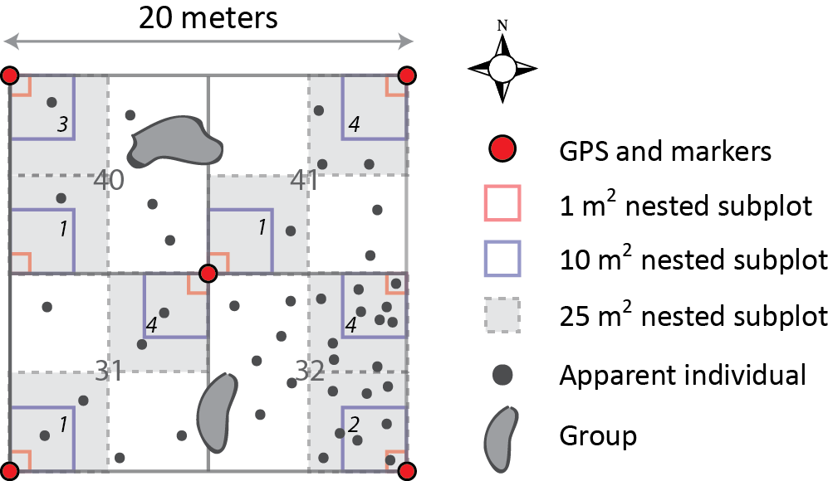

A 20m x 20m plot with heterogenously distributed vegetation. Grey numbers indicate subplot IDs, and black italic numbers indicate nested subplot IDs.

***Box 2:*** *Guidelines for selecting nested subplot size in a 40m x 40m base plot with heterogeneously distributed vegetation.*

In this scenario, we again consider whether nested subplots might be employed for measuring individuals with DBH < 10 cm that are heterogeneously distributed throughout the plot (Figure below). Here, assume subplots 23 and 41 are prescribed for sampling, so we do not consider subplots 21 and 39 further. An initial visual survey of the plot indicates that qualifying individuals are relatively dense in subplot 23 (n=81, including 2 groups), and are significantly less dense in subplot 41 (n=25, including 1 group). The critical difference here, compared to working in a smaller 20m x 20m plot (Scenario 1), is that we are required to sample n ≥ 20 individuals ***for at least one of the two subplots randomly selected for sampling; the other subplot does not need to meet the n ≥ 20 requirement***. Because stem density in subplot 23 is relatively high, we begin by assessing whether there is a nested subplot size that will give us n ≥ 20 individuals for subplot 23:

* 1 m2: 1 apparent individual sampled → insufficient sample size
* 10 m2: 5 apparent individuals sampled → insufficient sample size
* 25 m2: 12 apparent individuals sampled → insufficient sample size
* 100 m2: 45 apparent individuals sampled → sufficient sampling effort, use 100 m2 nested subplots throughout the entire plot.

Using the 100 m2 nested subplot for both of the two randomly selected subplots, our sampling effort looks like this:

* subplot 23, n=45
* subplot 41, n=13. We must also measure the portion of the group that overlaps nested subplot 4

***\*\*\*Note***: If subplot = 23 had NOT been randomly selected, the selected nested subplot size would be different for this example plot.

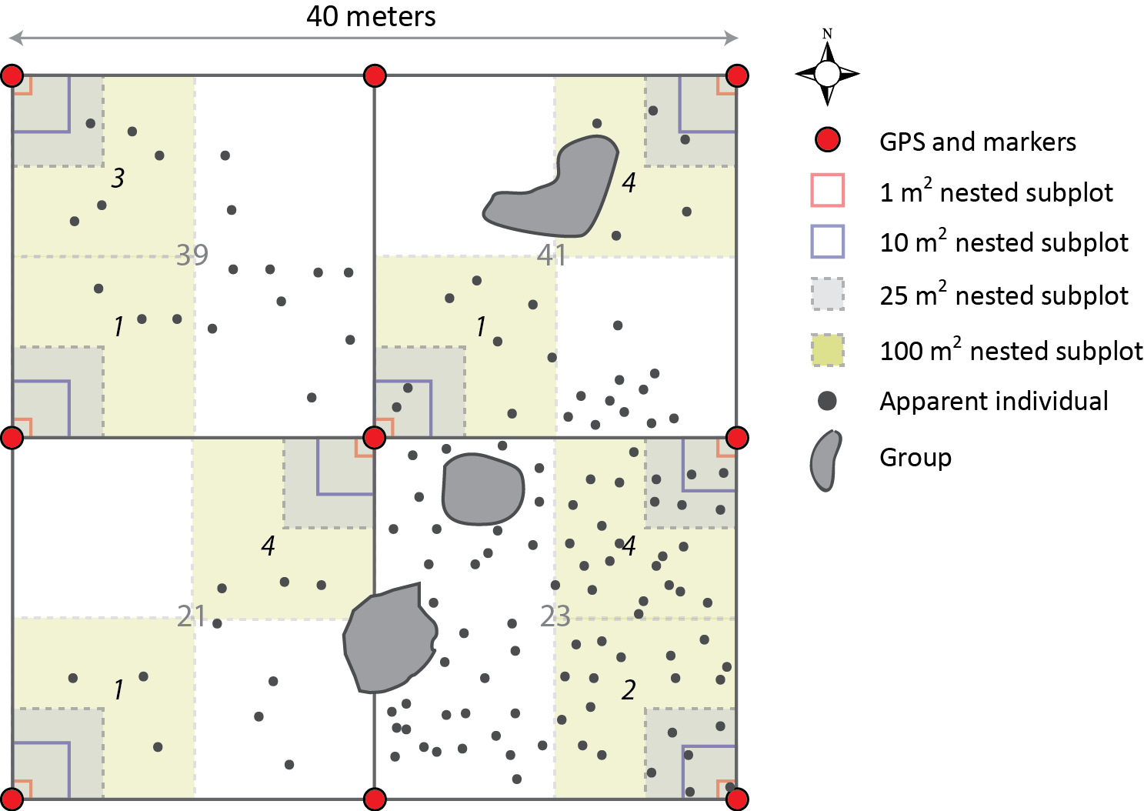

A 40m x 40m plot with heterogeneously distributed vegetation. Grey numbers indicate subplotIDs, and black italic numbers indicate nested subplotIDs.

Mapping and tagging requirements by growth form

Mapping and tagging requirements are guided by the principle that qualifying woody stems that are visible to AOP remote sensing instruments are mapped within NEON TOS plots. However, due to logistical constraints, mapping efforts within a given ecosystem are targeted toward those individuals in an ecosystem with the greatest biomass, AND that are visible to remote sensing instruments. The following are examples of how this strategy is executed in three common ecosystem types:

* *Closed canopy forest*: The overstory is typically comprised of trees with DBH ≥ 10 cm, and individuals that meet this DBH criterion are mapped. Small trees, saplings, shrubs, etc. in the understory with DBH < 10 cm are not mapped.
* *Rangeland shrub, Pinyon / Juniper, Scrub Oak, short-stature woodlands*: In these systems, it is possible for shrubs like *Artemisia tridentata* or *Prosopis spp*. (mesquite) to make up the overstory in plots that lack trees with DBH ≥ 10 cm. Here, these smaller stature individuals with DBH < 10 cm ARE mapped.
* *Savannah ecosystems:* These systems are a mixture of the previous two examples; trees with DBH ≥ 10 cm form the overstory in some parts of the plot, and shrubs/herbaceous plants form the “overstory” in other parts of the plot. For simplicity only individuals with DBH ≥ 10 cm are considered the overstory in savannah-like plots because these larger individuals comprise the majority of the plot biomass. Even though individuals with DBH < 10 cm may be visible to remote-sensing instruments throughout much of the plot, these individuals are NOT mapped if there are individuals with DBH ≥ 10 cm in any part of the plot prescribed for measurement.

Mapping and tagging requirements also vary by growth form:

* *Apparent Individuals*:
  + May be mapped as points; growth form specific mapping and tagging requirements are provided in **Table 9**.
  + Are tagged with a unique aluminum ID tag for repeat measurements.
  + Mapping and tagging data are recorded in the ‘Mapping and Tagging’ data sheet (RD[05]).
  + ‘Other’ non-woody individuals are measured like Apparent Individuals, but are not required to be mapped and tagged (except for tree palms).
* *Shrub Groups:* The locations of shrub groups are mapped relative to the plot with polygons and graph paper (SOP C.2), and location data are NOT entered into the NEON database. Individual stems within the group are not tagged.

**Table 9.** Summary of mapping and tagging requirements for each growth form.

| **Growth Form** | **Map** | **Stem Diameter Measurement Location** | **Tag type, location, and method** | **Additional required data** |
| --- | --- | --- | --- | --- |
| **Liana**  **(lia)** | Not mapped, but supporting stem tagID is recorded when applicable | 130 cm along the stem; see D.6 for complex cases | - Unique #  - 10 cm above stemDiameter measurement location  - Aluminum nail or loose wire, only one tag for each apparent individual despite branching | * - supporting stem tagID * - taxonID * - identificationQualifier * - nestedSubplotArea on ‘Plot Metadata’ sheet |
| **Single bole tree**  **(sbt)** | Record **stemDistance** and **stemAzimuth** relative to pointID (plot marker) | 130 cm along the bole; see Appendix D for complex cases | - Unique #  - 10 cm above stemDiameter measurement location   * + 1. - Aluminum nail | * - taxonID * - identificationQualifier |
| **Multi-bole tree**  **(mbt)** | Record **stemDistance** and **stemAzimuth** of largest bole relative to pointID (plot marker) | * 130 cm along qualifying boles if pith intersection occurs below 30 cm * See Appendix D if pith intersection is > 30 cm along stem | - Unique # on largest stem; tag largest live stem if possible  - A,B,C... on all additional qualifying stems; record additional tagIDs as ‘1234a’ on the datasheet  - 10 cm above stemDiameter measurement location   * + 1. - Aluminum nail | * - taxonID * - identificationQualifier |
| **Small tree**  **(smt)** | Record **stemDistance** and **stemAzimuth** relative to pointID if no overstory is present in the plot* | - 130 cm along qualifying boles  - See Appendix D if multi-bole and pith intersection is > 30 cm along stem | - Unique #  - 10 cm above stemDiameter measurement location (nail) **OR** a consistent, visible location (wire)  - Aluminum nail or loose wire as appropriate | * - taxonID * - identificationQualifier * - nestedSubplotArea on ‘Plot Metadata’ sheet |
| **Sapling**  **(sap)** | Not mapped | 10 cm along stem | - Unique #  - Consistent, visible location  - Loose aluminum wire | * - taxonID * - identificationQualifier * - nestedSubplotArea on ‘Plot Metadata’ sheet |
| **Single shrub**  **(sis)** | Record **stemDistance** and **stemAzimuth** of shrub center relative to pointID if no overstory is present in the plot* | For each qualifying emergent bole:   * 10 cm along the bole (if possible), AND * 130 cm along the bole on largest diameter fork of each emergent bole * See Appendix D for complex cases | - Unique # on largest emergent bole; tag largest live bole if possible  - no tag on additional qualifying boles; mark secondary emergent boles with lumber crayon  - 10 cm above stemDiameter measurement location (nail) **OR** ground level (wire)  -Aluminum nail or loose wire as appropriate | * - taxonID * - identificationQualifier * - nestedSubplotArea on ‘Plot Metadata’ sheet |
| **Small shrub**  **(sms)** | Record **stemDistance** and **stemAzimuth** of shrub center relative to pointID if no overstory is present in the plot* | 10 cm along each qualifying stem | - Unique #  - Consistent, visible location  - Loose aluminum wire | * - taxonID * - identificationQualifier * - nestedSubplotArea on ‘Plot Metadata’ sheet |
| **Shrub group**  **(sgr)** | Graph paper method used to calculate area only; location not recorded in NEON database | N/A | Not tagged, unique ID assigned per bout (may be tracked internally from year-to-year to facilitate re-measurement if desired) | * - nestedSubplotArea on ‘Plot Metadata’ sheet |
| **Ferns**  **(frn)** | Not mapped | Species dependent; see Appendix F | Not tagged | * - taxonID * - identificationQualifier * - nestedSubplotArea on ‘Plot Metadata’ sheet |
| **Palm**  **(plm)** | *Tree palms:* Record **stemDistance** and **stemAzimuth** relative to pointID (plot marker)  *Other palms:*  Relative position if no overstory is present in the plot | Species dependent; see Appendix F | - Unique #  - 10 cm above stemDiameter measurement location (nail) **OR** ground level (wire)  - Aluminum nail or loose wire as appropriate | * - taxonID * - identificationQualifier * - nestedSubplotArea on ‘Plot Metadata’ sheet |
| **Agave (agv)**  **Yucca (yuc)** | Not mapped | N/A | Not tagged | * - taxonID * - identificationQualifier * - nestedSubplotArea on ‘Plot Metadata’ sheet |

* For mapping and tagging, ‘overstory’ is defined as the presence of at least one individual in the plot or selected subplots with DBH ≥ 10 cm; site-specific exceptions may apply (see Appendix I).

***Exceptions and special considerations***

There are numerous instances in which the generalized guidelines provided above in **Table 9** are insufficient when it comes to deciding on an appropriate measurementHeight and tagging location. Complex and non-standard individuals that require special consideration, are summarized in **Table 10**, and illustrated in detail in Appendix D. Site-specific modifications are described in Appendix I.

**Table 10.** Guidelines for determining the appropriate measurement and tagging location for situations not covered in Table 9.

| **Measurement location and tagging guidelines for complex woody stems** | |
| --- | --- |
| **Stem/Site Characteristics** | **measurementHeight and tag location** |
| Growing on sloped or uneven terrain | Measure stem diameter 130 cm from uphill side, tag 10 cm above measurementHeight. |
| Thickened base | Measure stem diameter 50 cm above the point where stem becomes ‘regular’ again. |
| Leaning or twisted stems | Measure stemDiameter 130 cm along the underside of the stem; diameter measurement is perpendicular to the direction of stem growth, not parallel to ground. Tag 10 cm above measurementHeight. |
| Stems with anomalies at 130 cm (e.g., bulge, node/branch, or minor, localized damage). | Measure above the anomaly where stem becomes ‘regular’ again. Tag 10 cm above measurementHeight. When damage is a major feature of the stem, do not move the measurementHeight and tag location. |
| Deep litter/duff layer heaped around bole base | The measurementHeight and tagging location are determined from ground level, not the top of the duff layer. |
| Bole / stem is broken | * For break points ≥ 130 cm height, follow standard measurementHeight and tagging guidelines. * For ‘sbt’, ‘mbt’ and ‘smt’, ignore live or dead broken boles < 130 cm height, but follow guidelines for resprouts if present (see below). * For ‘sap’ and ‘sms’, broken stems < 30 cm length are ignored (live and dead, see Appendix D). Tag largest, live qualifying stem. |
| Multi-bole tree with mix of live and dead stems (includes stump ≥ 130 cm height and DBH ≥ 10 cm w/ re-sprouts) | * Location of measurementHeight and tag depends on where pith of resprout intersects with pith of main bole. See Appendix D. * Broken boles, either dead or alive, must be > 130 cm height to qualify for tagging. * Resprouts NOT required to be ⅓ diameter of main bole when main bole is dead. |
| Downed live, with vertically growing resprouts | Measurement and tagging strategy depends on whether the pith of the downed bole is above or below the forest floor. See Appendix D. |
| Standing dead | * For standing dead ≥ 130 cm length, follow standard measurementHeight and tagging guidelines. * For ‘sbt’, ‘mbt’, ‘smt’ and ‘sis’, dead boles < 130 cm length are ignored. * For ‘sap’ and ‘sms’, dead stems < 30 cm length are ignored and not tagged (see Appendix D). |
| Leaning dead | * If lean is < 45° off vertical, measure and tag same as standing dead; height measured is total height above the ground, NOT total stem length; * If lean is ≥ 45°, ignore stem, will be assessed as Coarse Downed Wood (except in the case of decumbent growth forms such as manzanita species). |
| Plot burned since previous bout | Do not change measurement strategy. Do not need to search for fallen, tagged individuals for re-measurement. |

Stem mapping, tagging, and taxon identification

The procedure described here only applies to apparent individuals. Stems must be ≥ 50% rooted in the plot in order to be considered ‘in’ and included in long term monitoring. Dead individuals are tagged and mapped if they are not leaning > 45° from vertical (but note this criterion does not apply to decumbent growth forms). Data collected as part of this SOP are recorded in the ‘**Mapping and Tagging**’ ingest table. If structure measurements (SOP C) are made at the same time as ‘Mapping and Tagging’ data are collected, record structure data in the ‘**Apparent Individuals**’ ingest table.

This procedure is for mapping trees and shrubs within a plot or subplot relative to established plot markers (see RD[08] for details). The mapping procedure will be completed for:

* Single bole trees with **stemDiameter** ≥ 10 cm,
* Multi-bole trees with **stemDiameter** ≥ 10 cm for at least one bole,
* Single shrubs (only if no trees with DBH ≥ 10 cm are present in the entire plot),
* Small trees (only if no trees with DBH ≥ 10 cm are present in the entire plot), and
* Small shrubs (only if no trees with DBH ≥ 10 cm are present in the entire plot)

***Note***: It may be more efficient to ID and tag all individuals in the plot, and then map all of these individuals. Other workflows are also possible: use the work flow that is optimal for your plots.

Mapping Tools

The steps below assume the use of a laser rangefinder; however, a meter tape and declination-corrected compass may be used on slopes < 20% if the tape is not prevented from being stretched straight by understory vegetation. Appropriate training is required to accurately use a compass.

***To determine taxonID, map, and tag woody stems:***

1. Delineate the plot or subplot(s). Use existing plot markers, the 50 m tapes, and chaining pins to carefully delineate the plot and subplots. In this case, it is not necessary to pay attention to whether the plot is sloped or flat: the tape is used only to help determine which stems are “in” versus “out” of the plot.

* To be considered “in,” an individual must be ≥ 50% rooted within the plot. For multi-stemmed individuals, ≥ 50% of the emergent stems must originate from within the plot.
* If shrub thickets prevent stretching tape, a rangefinder may also be used for “in” versus “out” determination.

1. Record required ‘Mapping and Tagging’ sampling metadata:

* **plotID**; *SITE_XXX* format
* **yearBoutBegan** and **date**; typically the former is part of the latter, but may be different if the bout began in a previous year and continued over the Dec 31st to Jan 1st transition.
* **nestedSubplotArea**(s); for use in the field only, should match ‘Plot Metadata’.
* **identificationReferences**; list dichotomous keys, regional flora guides used to identify plants.

1. Select a stem, and determine the appropriate measurementHeight using **Table 9**, **Table 10**, and Appendix D. Attach a pre-numbered aluminum tag according to guidelines in **Table 9**; this number is the **tagID.**

* Mark the measurementHeight on the qualifying stem(s) using lumber crayon or equivalent.
* When many emergent boles/stems are in close proximity, and it is difficult to distinguish ‘individuals,’ it is best to treat each qualifying emergent bole/stem as an individual.
* If an individual has already been mapped, and is associated with an incorrect **tagID** (as noted by the **tagStatus** field in the Apparent Individual table), record:
  + **tagID**; the new, correct identifier.
  + **previousTagID**; the previous, incorrect identifier.

1. Record the **taxonID** and **identificationQualifer** code if needed. Critical points to collecting quality **taxonID** and **idQ** data:

* The **taxonID** should be a code from the NEON master list of plant species codes (found in the ‘taxonTables’ folder of the FOPS / TOS ‘Sampling Support Documentation’ Sharepoint library), and qualified according to technician confidence (**Table 11**).
* Technicians are encouraged to use ONLY the NEON master code on all datasheets. In the event that a code different from the NEON master code is used on a datasheet, the full **scientificName** associated with that code must be provided with *each* datasheet on which the non-NEON code is used, either via annotation, or by attaching a key to the datasheet.
* **identificationQualifier**: The NEON master taxon lists provide codes for instances when identification below a given taxonomic rank (e.g., family or genus) cannot be made.
  + An **idQ** is used in combination with a ‘sp.’ or ‘spp.’ in the scientific name; ‘sp.’ indicates only one unknown species is involved, and ‘spp.’ Indicates multiple possible species.
    - If the genus of a specimen is obvious, and the specimen is one of up to 3 species, assign the specimen to the best matched species, and then assign ‘idQ = CS’.
  + When a genus- or family-level code is selected, an identification qualifier is not needed, unless for example, the genus is uncertain.
    - *Example:* If you record **taxonID =** “PINUS”, do NOT record **idQ** = “cf. species”; it is already clear that you do not know the species based on the fact that a Genus-level code was reported in **taxonID**.
* Morphospecies:
  + If a morphospeciesID is needed, record the **taxonID** to the best of your ability IN ADDITION to the morphospeciesID.
  + The use of morphospeciesIDs is expected during the course of this work. If the domain staff are able to identify a morphospecies at a later time, the **taxonID** associated with that morphospeciesID must be provided with the data sheet, either via attaching a key, or via annotation prior to data entry (see RD[04]).
  + If domain staff are not able to identify a given morphospecies prior to data entry, the morphospecies ID must be recorded in the morphospecies ID list (found in the ‘morphospeciesTracking’ folder of the FOPS / TOS Sharepoint library).
* Cryptic species:
  + Issues with cryptic species may arise if two morphologically similar species may co-occur at a given site. To account for this, members of cryptic pairs or groups should be added to NEON master taxon lists. New pairs / groups must be entered in the ‘crypticSpeciesGroups’ spreadsheet in the ‘taxonTables’ folder of the ‘Sampling Support Documentation’ Sharepoint library.
* When stem **plantStatus =** 2 (standing dead), assign to species if possible. If the species cannot be determined, assign to genus, family, or unknown hardwood (2Plant-H) / unknown softwood (2Plant-S), in that order of preference.
* If **taxonID** is unknown and the stem is alive, assign a morphospecies ID as indicated above, obtain leaf, bark, and/or reproductive part samples (e.g., cones, nuts), and bring back to the lab to identify.

**Table 11.** Available identificationQualifier codes for species ID. An idQ is not necessary if the taxonID is unambiguous.

| **idQ code** | **identificationQualifier description** |
| --- | --- |
| CS | *cf. species*: roughly equals but "not sure" about the species |
| AS | *aff. species*: similar to, but is not the species |
| CG | *cf. genus*: roughly equals but "not sure" about the genus |
| AG | *aff. genus*: similar to, but is not the genus |
| CF | *cf. family*: roughly equals but "not sure" about the family |
| AF | *aff. family*: similar to, but is not the family |
| CV | *cf. variety:* roughly equals but “not sure” about the variety |
| AV | *aff. variety:* similar to, but is not the variety |

1. If adding the sample to a domain-specific reference collection would be helpful, collect and process unknown morphospecies according to the plant diversity protocol (RD[07]).
2. Record the three letter **growthForm** code. This is assessed for each individual, rather than by species. Refer to **Table 7** for growthForm codes and definitions.

***To map qualifying woody vegetation:***

1. Mount the laser rangefinder on the non-magnetic tripod, and position the laser rangefinder directly over an existing plot marker for which high-resolution GPS coordinates have already been recorded.

* If at all possible, use points on the perimeter of the plot to map individuals, and avoid using the plot centroid for mapping. Over-reliance on the plot centroid for mapping has resulted in unacceptable trampling of the 1 m2 nested subplots.
* A tripod is critical because it ensures the rangefinder stays centered over the chosen pointID. If a tripod is not used, the tendency is to swing the rangefinder from side to side while the feet remain on the pointID marker, which introduces errors in azimuth and distance.
* Care should be taken to avoid placing tripod legs within nested subplots used for Plant Diversity measurements, and to avoid trampling Plant Diversity nested subplots.

1. Record the **pointID**. This is the plot marker number over which the laser rangefinder is positioned.
   1. Refer to Appendix G if plot markers are not numbered.
2. Record the **stemDistance;** nearest 0.1 m. This is the horizontal distance from the plot marker to the base of the main stem, or the center of a shrub.
   1. Press “Power/Fire” to turn on the TruPulse.
   2. Set the unit to Target Mode = Filter. Press either the ▲ or ▼ button until **HD** (i.e. Horizontal Distance) appears in the viewfinder.
   3. Person 1: Hold the reflective surface at the base of the stem so that it is visible to Person 2.
   4. Person 2: Look through the laser rangefinder viewfinder, aim the crosshairs at the reflective surface held by Person 1, and press and hold “Power/Fire” until the distance is displayed in the viewfinder; record this distance.
3. Record the **stemAzimuth;** nearest 0.1 degree. This is the angle relative to True North from the chosen plot marker to the base of the main stem or center of shrub.
   1. After recording the **HD** to the stem above, press ▲ three times until **AZ** (i.e. azimuth from True North) appears in the viewfinder, and record the displayed angle (in degrees).
   2. The angle should be preceded by a “**d**” indicating that declination has been set for the laser rangefinder at your current location (setting the declination is described in RD[09]).
4. Should you encounter a downed individual with a Vegetation Structure **tagID**:
   1. If the individual has DBH ≥ 2 cm:
      1. If the site host allows, leave the tag in place, as the downed individual may be tallied via the NEON Coarse Downed Wood protocol.
      2. Record **tagStatus** = ‘ok’
      3. Record **plantStatus** = 16 (downed); and
      4. In the **remarks**, indicate the % of the downed bole in contact with the ground.
   2. If the individual has DBH < 2 cm:
      1. Remove the tag from the downed individual.
      2. Record **tagStatus** = ‘removed’
      3. Record **plantStatus** = 16 (downed)

*Tip:* It is helpful to mark trees you have just measured with a small length of flagging in order to track work progress. All temporary flagging must be removed once data have been collected from all trees within a given subplot.

###### Biomass/Productivity Measurements

The data collected as part of this procedure will be used as inputs to allometric equations that enable estimates of individuals’ biomass. Annual re-measurement of individuals will enable calculation of annual Aboveground Net Primary Production (ANPP). Generalized allometric equations vary by growth form and require different types of information. Here we describe field techniques for measuring stem diameter, height, crown diameters, canopy area, and methods specific to unique growth forms such as ferns. To determine which measurements are required for a specific growth form refer to **Table 12**.

Woody stemmed vegetation may exhibit numerous growth forms – from single, straight boles to multiple curved, branched stems, to stems with adventitious roots that emerge some distance from the ground. Because of this variety, consistently choosing the appropriate measurement point is paramount. With some modifications, this protocol adopts guidelines established by the U.S. Forest Service (2012) for measuring tree species. Shrubs are measured according to Lutz et al. (2014), and liana measurement guidelines come from Gerwing et al. (2006) and Schnitzer et al. (2008). Unless otherwise noted, diameter measurements are taken at a standard distance of 130 cm along the bole (breast height, DBH) and/or at 10 cm along the bole (ddh).

Vegetation structure data are collected systematically from qualifying apparent individuals, groups, and portions of groups rooted inside each plot. All individuals with DBH ≥ 10 cm within the prescribed measurement area(s) of a plot or subplot are mapped and measured regardless of density; however, for small diameter trees and saplings, shrubs, lianas, and ‘other’ qualifying plants (e.g., ferns), nested subplots may be used to standardize sampling effort (Sections B.2 and B.3). **Each plot that is visited must be assessed for the presence of these growth forms, and measured accordingly.** Assessments for the presence of growth forms should take place every time a plot is measured. During annual re-measurement of a plot, pay careful attention to:

* Map, measure, and tag new stems that now meet the minimum 10 cm DBH cutoff.
* Update **plantStatus** as some individuals may have died, and others may have become damaged.
* Update **growthForm**, as some individuals may have changed categories.

Measuring Apparent Individuals

The measurements required for an individual are dependent on the assigned **growthForm** (**Table 12**).Record stem and canopy measurement data in the ‘**Apparent Individuals**’ ingest table.

**Table 12**. Summary of required measurements for each growth form; it is assumed that required taxonomic data are recorded on the ‘Mapping and Tagging’ datasheet as part of SOP B implementation. Note that individuals may change growthForm from one year to the next, necessitating potentially different measurements (e.g., a change from ‘sapling’ to ‘small tree’).

| **Growth Form** | **Stem Diameter** | **Height** | **Crown Diameter** | **Additional Measurements** |
| --- | --- | --- | --- | --- |
| **Liana**  **(lia)** | - stemDiameter (DBH)  - measurementHeight  - see Appendix E for complex cases | Not measured | Not measured | - plantStatus |
| **Single bole tree**  **(sbt)** | - stemDiameter (DBH)  - measurementHeight  - See **Table 10** and Appendix D.1 for complex cases | - vdApexHeight = Maximum height above observer  - vdBaseHeight = Height from observer to base of tree (typically a negative number) | - Distributed Plots only  - Maximum diameter  - Perpendicular to max | - plantStatus  - canopyPosition (Distributed Plots only) |
| **Multi-bole tree (mbt)** | - stemDiameter (DBH, per bole)  - See Appendix D.2 to determine correct measurementHeight | Measure per individual, not per bole.  - vdApexHeight = Maximum height of tallest bole above observer (not per bole)  - vdBaseHeight = Height from observer to base of tree (typically a negative number) | - Distributed Plots only  - Per individual, not per bole  - Maximum diameter  - Perpendicular to max | - plantStatus (per bole)  - canopyPosition (not per bole, Distributed Plots only) |
| **Small tree (smt)** | - stemDiameter (DBH)  - measurementHeight  - See **Table 10** and Appendix D for complex cases  - Measure multiple boles if applicable (**Figure 4**) | Measure per individual (not per bole).  - vdApexHeight (top) and vdBaseHeight (ground)  - Record vdBaseHeight = 0 if total height is measured from the ground with a collapsible ruler | - Distributed Plots with no overstory only  - Per individual, not per bole  - Maximum diameter  - Perpendicular to max | - plantStatus (per emergent bole) |
| **Sapling (sap)** | - basalStemDiameter (ddh)  - measurementHeight  - Measure multiple emergent boles if present (Appendix D.6) | Measure per individual, not per stem.  - vdApexHeight = Maximum height  - Record vdBaseHeight = 0 if total height is measured from the ground with a collapsible ruler | Not measured | - plantStatus (per emergent stem) |
| **Single shrub (sis)** | - basalStemDiameter (ddh, (per qualifying emergent bole)  - stemDiameter (DBH, (only on largest diameter fork per emergent bole)  - ddh and DBH measurementHeight  - See Appendix D.5 for complex cases | Measure per individual, not per bole.  - vdApexHeight = Maximum height  - Record vdBaseHeight = 0 if total height is measured from the ground with a collapsible ruler | - Per individual, not per bole.  - Maximum diameter  - Perpendicular to max | - plantStatus (per emergent bole)  - shape  - If shape=icn: maxBaseCrownDiameter, and ninetyBaseCrownDiameter  - If shape=elp: height to crown base |
| **Small shrub (sms)** | - basalStemDiameter (ddh, (per qualifying emergent stem)  - measurementHeight  - Measure multiple emergent stems if present (Appendix D.6)  - Broken emergent stems must be ≥ 30 cm height (or stem length) to qualify for measurement (Appendix D.6). | Measure per individual, not per stem.  - vdApexHeight = Maximum height  - Record vdBaseHeight = 0 if total height is measured from the ground with a collapsible ruler | - Per individual, not per stem  - Maximum diameter  - Perpendicular to max | - plantStatus (per emergent stem)  - If shape=icn: maxBaseCrownDiameter, and ninetyBaseCrownDiameter  - If shape=sph: height to canopy base |
| **Shrub group (sgr)** | Not measured | - Five points that best represent overall height of the group | Total canopy area; graph paper method | - % contribution to total volume (per species)  - % live (per species)  - % dead (per species) |
| **Fern (frn)** | - Species dependent; see Appendix F | - Tree ferns only  - Maximum height  - Record vdBaseHeight = 0 if total height is measured from the ground with a collapsible ruler | Not measured | - plantStatus  - Species dependent; see Appendix F |
| **Palm (plm)** | - stemDiameter (DBH, (tree palms only)  - If present, record ‘DBH contains leaf base’ in **remarks** field  - See Appendix F | - Maximum height  - For tree palms, typically measure vdApexHeight (top) and vdBaseHeight (ground)  - Record vdBaseHeight = 0 if total height is measured from the ground with a collapsible ruler | Species dependent; see Appendix F | - plantStatus  - Species dependent; see Appendix F |
| **Agave (agv)**  **Yucca (yuc)** | Not measured | - Maximum height  - Record vdBaseHeight = 0 if total height is measured from the ground with a collapsible ruler | - Maximum diameter  - Perpendicular to max | - plantStatus |
| **Bear Grass (xer)** | * basalStemDiameter (per flowering stem) | Not measured | Not measured | * meanLeafLength |
| **Ocotillo (oco)** | Not measured | - Measure per individual, not per stem.  - Maximum height  - Record vdBaseHeight = 0 if total height is measured from the ground with a collapsible ruler | - maxBase CrownDiameter  - ninetyBase CrownDiameter | - stemNumber |

***Plot Delineation and Assessment:***

1. **Check the ‘Plot Metadata’ datasheet to determine whether a plot has been measured before, and if so, which nested subplot area must be used.**

* *If a plot has been measured before*, it is important to use the same subplot size each year, unless a change in nested subplot size has been discussed with and approved by NEON Science. Within a given plot, each of the following groups of growth forms may be measured with a different nested subplot size:
* lianas
* smt + sap + sis + sms + shrub groups
* ‘other’ = agv + yuc + frn + plm + xer + oco
* *If a plot has NOT been measured before,* return to SOP B to assign nested subplots (if required), and to perform speciesID, and mapping and tagging activities.

1. Delineate the plot or subplot. Use existing plot markers, 50 m tapes, and chaining pins to carefully delineate the plot / subplot boundaries.

* It is not necessary to pay attention to whether the plot is sloped or flat: the tape is used only to help determine which stems are “in” versus “out” of the plot.
* Individuals are only measured when ≥ 50% of the individual (or ≥ 50% of the stems, for a multi-stemmed individual) are rooted within the measurement area.
* Refer to the Plot Establishment Protocol (RD[08]) for a review of tape wrapping techniques that can be used to delineate modules or subplots.

1. Delineate nested subplots. The one-sided length of the nested subplots are listed above in Section B.2, **Table 8**.

* If measuring a plot for the first time, be sure to record the size of nested subplot used in the ‘Plot Metadata’ datasheet.

1. Survey the plot to identify individuals previously not measured that now qualify as one of the growthForms listed in **Table 7**.

* For new recruits, return to SOP B, and record required data on the ‘Mapping & Tagging’data sheet.

***For each qualifying Apparent Individual:***

1. Record in the ‘Apparent Individuals’ ingest table (RD[05]):

* **subplotID** and **nestedSubplotID**
  + - To enable work tracking within a plot, these fields may be pre-populated from ‘Mapping & Tagging’ or previous year’s ‘Apparent Individuals’ data sheets.
  + **tagID** and **taxonID;** These fields may also be pre-populated, as above.
* The **taxonID** and **idQ** fields may need to be updated to reflect improved identifications and current knowledge.
* **tagStatus**; choose one of the following options:
  + **ok**; Tag is attached, and consistent with previously entered value.
  + **replaced**; Tag no longer attached, and has been re-made with same number.
  + **mislabeled**; tagID was incorrectly recorded, and has been re-assigned.
  + **untagged**; Previously measured individual that no longer has a unique tagID assigned; cannot determine previous tagID. Assign new tagID.
  + **unknown**; no tag attached, and unclear whether individual was previously measured. Assign new tagID.
  + **removed;** Tag removed because individual is no longer measured on a permanent basis (e.g., tree falls down and dies).

1. Determine the **measurementHeight**(s) for each of the qualifying stems of the individual – i.e., the distance along the bole(s), beginning from where the bole emerges from the ground, at which the **stemDiameter** is measured (**Table 9** and Appendix D).

* The measurementHeight is determined independently for multiple emergent boles that are part of the same individual.
* In many cases, the measurement location will already be marked with lumber crayon following the ‘Mapping and Tagging’ activity (SOP B.4).

1. Mark (or re-mark) the stem at the desired measurementHeight with lumber crayon to enable repeat measurements at the exact same location.

* Mark stems with DBH ≥ 30 cm at multiple points around the bole to ensure accurate re-measurement.
* Re-mark the stem if the lumber crayon is faded or difficult to discern.

1. Assess whether a diameter tape or calipers should be used to measure stem diameter.

* ***Use a diameter tape for***: Self-supporting stems with DBH ≥ 5 cm, AND that do NOT have lianas that will interfere with accurate diameter measurement.
* ***Use calipers for***:
  + Self-supporting stems with DBH < 5 cm; use calipers to measure the stem at its widest point, and perpendicular to its widest point. Calculate the average, and record.
  + Self-supporting stems with DBH ≥ 5 cm that DO have lianas that will interfere with accurate diameter measurement; use calipers to measure the stem at its widest point (excluding lianas), and perpendicular to its widest point. Calculate the average, and record.
  + Lianas

1. Meaure the **stemDiameter** at the required **measurementHeight**(s). Remember, both DBH *and* ddh are required when growthForm = ‘sis’. All diameter cutoffs are hard cutoffs – do not round.
   1. Place the diameter tape or calipers directly over the marking(s) from step (7). Remember:

* For large boles, the tape must not slip above or below the desired measurementHeight.
  1. Record in the ‘Apparent Individuals’ ingest table (RD[05]):
* **stemDiameter**: The diameter of the bole perpendicular to the pith, typically 130 cm along the bole for DBH; nearest 0.1 cm. Not recorded when growthForm = ‘sap’ or ‘sms’.
* **basalStemDiameter**: The basal diameter of the bole, typically 10 cm above the ground; nearest 0.1 cm. Recorded only when growthForm = ‘sap’, ‘sis’, or ‘sms’.
* **measurementHeight**: Distance along the bole at which the **stemDiameter** or **basalStemDiameter** is actually measured; nearest 1 cm.

1. Determine and record the **growthForm** for the individual.

* Use values of **stemDiameter** from step (9) and definitions of **growthForm** from .
* **growthForm** values may change from year to year (e.g., ‘sap’ to ‘smt’).

1. Record the **plantStatus** for each qualifying bole/stem according to the definitions in **Table 13**.

* See Appendix D.4 for how to deal with multi-bole individuals with mixed plantStatus.

**Table 13.** List of **plantStatus** codes and their definitions.

| **Code** | **Description** |
| --- | --- |
| 1 | **Live** – any live Apparent Individual (new, re-measured or ingrowth) that is of typical healthy status for the ecosystem in question. E.g., if trace amounts of insect damage or foliar disease are typical on the majority of individuals, use this code rather than code 4 or 5 below. |
| 2 | **Standing dead –** any dead individual, or standing dead bole within a multi-bole individual, regardless of cause of death. The entire tree or bole must be dead, and the main bole is NOT broken. For dead, broken boles see additional code below. Indicate factors associated with death in order of importance in the **remarks** field. Potential causes of death include:   * Biotic: Suppression, animal damage, mistletoe * Disease: Blister rust, rot, canker, other (specify), unknown * Insect: Bark, defoliating, other; specify insect species if possible * Physical: Crown damage, crushed, lightning, other (specify if possible) * Fire: Crown scorch, crown combustion, bole/stem scorch, bole/stem combustion, burned through at base (for small trees, due to litter & duff burning around base), other (describe). * Unknown: A last resort category; may be applicable if individual is long dead. |
| 3 | **Removed** – an individual that has been cut and removed by direct human activity related to harvesting, silviculture or land clearing (re-measurement plots only). |
| 4 | **Live, insect damaged** – Visible damage caused by insects that exceeds trace amounts that may be present on typically healthy trees; note ‘crown’ or ‘bole’ damage in **remarks**, and indicate type of insect causing damage if possible (e.g., Mountain Pine Beetle, Gypsy Moth, etc.) |
| 5 | **Live, disease damaged** – Visible damage caused by disease that exceeds trace amounts that may be present on typically healthy trees; note ‘crown’ or ‘bole’ damage in **remarks**, and indicate type of disease causing damage if possible (e.g., Blister Rust, rot, canker, other (specify), unknown. |
| 6 | **Live, physically damaged** – Visible damage not caused by insects or disease, but of known origin; note ‘crown’ or ‘bole’ damage in **remarks**, and indicate type of physical damage (e.g., bole scar, girdling, snow/ice damage, crushed, lightning, crown scorch, bole scorch) |
| 7 | **Live, other damage** – Visible damage of unknown origin; note ‘crown’ or ‘bole’ damage in **remarks**, and note cause if possible. |
| 8 | **No longer qualifies** – Individual is still alive and may qualify in the future, but does not currently qualify; note reason in **remarks.** Reasons for not measuring include: Consumption of qualifying boles / stems by fire, blow-down of qualifying boles / stems, etc. |
| 9 | **Live, broken bole/stem** – individual with broken top, with broken main bole and ascending leaders (that may or may not be taller than the break point), or that is broken and dead at top but live below, etc. Indicate factors that may have caused the break and other damage in order of importance in the **remarks** field. |
| 10 | **Dead, broken bole/stem** –all parts of the broken bole or stem are dead; may have broken spike top, or dead leaders ascending beyond the break point. Indicate factors associated with death and the source of damage in order of importance in the **remarks** field. |
| 11 | **Lost, burned –** A previously measured individual that is not measured in the current bout because the plot has been burned, and the individual could not be re-located for measurement. Cause of loss is presumed to be fire. |
| 12 | **Lost, herbivory –** A previously measured individual that is not measured in the current bout because the individual could not be re-located for measurement. Cause of loss is presumed to be herbivory. |
| 13 | **Lost, presumed dead** – A previously measured individual that is not measured in the current bout because it could not be re-located for measurement. The individual is presumed dead based on evidence within the plot. Note presumed cause of death in the **remarks** field (e.g., blowdown event). |
| 14 | **Lost, tag damage** –A previously measured individual that is not measured in the current bout due to inability to re-locate because of widespread damage to tags within a plot. |
| 15 | **Lost, fate unknown** – A previously measured individual that is not measured in the current bout because the individual could not be re-located. |
| 16 | **Downed** – Part or all of a dead tree is down, and in contact with the ground. In the **remarks**, record the percent of the down bole portion that is in direct contact with the ground. |

1. Use **Table 12** and the **growthForm** assigned in step (10) to determine required **height** measurements. Record **vdApexHeight** and **vdBaseHeight** if required.

* **vdApexHeight**: The definition depends on the measurement method.
  + *Rangefinder:* The vertical distance between the top of the crown and the rangefinder (typically a positive number); nearest 0.1 m
  + *Collapsible ruler*: The vertical distance between the top of the crown and the ground; nearest 0.1 m
* **vdBaseHeight**:
  + *Rangefinder:* The vertical distance between the rangefinder and the tree base where it emerges from the ground (typically a negative number); nearest 0.1 m
  + *Collapsible ruler*: Enter ‘0’, since **vdApexHeight** already represents total **height** above ground when measured with a collapsible ruler.

Complicating factors: Broken Individuals

***I. Broken boles: sbt***

When either live or dead broken ‘sbt’ individuals > 130 cm height are encountered:

* Record **plantStatus**  = 9 or 10 (see **Table 13**).
* Skip step (13) below, and do NOT record **crown diameter** data.
* Record **breakDiameter, vdApexBreakHeight** and **vdBaseBreakHeight.**
  + If using paper data sheets, record on the next row of the data sheet as **remarks.**
  + If leader branches ascend higher than the break height, **vdApexHeight** will be larger than **vdApexBreakHeight**.
  + If the break height is the highest point, the value recorded for **vdApexBreakHeight** will be the same as that recorded for **vdApexHeight**.
  1. *If the broken top of the bole can be found nearby on the ground:*
     1. Search for the top of the broken bole that has fallen to the ground.
     2. Measure the **breakDiameter** of the fallen bole as near the break point as possible. Measure two diameters with calipers and record the average if a diameter tape cannot be used.
  2. *If the broken top cannot be found,* or it cannot be determined which broken top matches the broken bole of interest: Two people may use calipers to estimate the diameter at the breakpoint.
     1. Person 1: Stand away from the broken bole at a sufficient distance such that you can see the breakpoint AND the base of the bole (i.e., the same distance required for measuring the height of the break).
     2. Person 2: Stand in front of the broken bole with the caliper jaws open and pointing up.
     3. Person 2 directs Person 1 to open the calipers until the jaw gap appears to match the diameter at the breakpoint (squinting may help).

***II. Broken boles: mbt***

When either live or dead broken boles > 130 cm height are part of a multi-bole tree:

1. *If a subset of the boles are broken:*
2. Record **plantStatus** individually for each bole (see **Table 13**).
3. Record **crown diameter** measurements once for the intact bole(s) (step 13 below). Record these values as the crown diameter entries for the largest, unbroken bole.
4. Measure and record **breakDiameter**, **vdApexBreakHeight**, and **vdBaseBreakHeight** for the broken bole(s) on separate rows of the data sheet as described above for broken ‘sbt.’
5. *If all of the boles are broken:*
6. Record **plantStatus** individually for each bole (see **Table 13**).
7. Skip step (13) below and do NOT record **crown diameter** data.
8. Measure and record **breakDiameter**, **vdApexBreakHeight**, and **vdBaseBreakHeight** for each broken bole on separate rows of the data sheet as describe above for broken ‘sbt.’

***III. Broken boles: smt***

1. When a single-bole ‘smt’ has broken, or all boles of a multi-bole ‘smt’ have broken, and height is now < 130 cm:
   1. Assign **plantStatus** = 8 (no longer qualifies), and do not measure in the current year.
   2. Continue to monitor in future years, as individual may again qualify for measurement.
2. When one or more boles of a small multi-bole ‘smt’ have broken, and are now < 130 cm height:
   1. For broken boles that do not qualify, assign status = 8 as above for single-bole ‘smt’.
   2. Continue to measure qualifying emergent boles as normal.
   3. Measurement of **crown** diameter does not include broken boles.
3. When one or more boles of a small multi-bole ‘smt’ have broken, and are now ≥ 130 cm height:
   1. Record **plantStatus** = 9 or 10 for each broken bole.
   2. Measure **crown** diameter for intact boles; do not include broken boles in diameter measurement.
   3. Measure **breakDiameter** as for ‘sbt’, above.

***IV. Broken boles: sis***

1. When an emergent bole is broken and is < 130 cm height:
   1. Assign **plantStatus** = 8, and do not measure in the current year.
   2. **basalStemDiameter** = do not measure.
   3. Measure **crown** diameter for intact boles; do not include broken boles in diameter measurement.
2. When an emergent bole is broken and is ≥ 130 cm height:
   1. Record **plantStatus** = 9 or 10 for each broken bole.
   2. Measure **crown** diameter for intact boles; do not include broken boles in diameter measurement.
3. When all previously qualifying emergent boles are broken, and are < 130 cm height:
   1. Assign **plantStatus** = 8 for each bole.
   2. Do not measure **crown** diameter.
   3. Continue to monitor in future years, as individual may again qualify for measurement.

***V. Broken boles: sap and sms***

1. When an emergent stem has ddh ≥ 1 cm, and is broken and < 30 cm height (or stem length):
   1. Do not measure ddh.
   2. Measure **crown** diameter for intact stems; do not include broken stems in diameter measurement.
   3. If all qualifying emergent stems are broken and < 30 cm height, no measurements are made.
2. When an emergent stem has ddh ≥ 1 cm, and is broken and ≥ 30 cm height (or stem length):
   1. Assign **plantStatus** = 9 or 10
   2. Measure ddh.
   3. Measure **crown** diameter for intact stems; do not include broken stems in diameter measurement.
   4. If all qualifying emergent stems are broken and ≥ 30 cm height, no **crown** measurements are made.
3. Use **Table 12** and the **growthForm** assigned in step (10) to determine required **crown** measurements. Crown diameters can be measured via either of the two techniques in RD[09].

* The **crown** dimensions may include live and dead material from intact boles / stems. However, do not include broken boles in measured **crown** dimensions.
* Crown dimensionsare required once per *individual*  for the following growth forms (as opposed to per emergent bole):
  + ‘sis’ and ‘sms’: Crown dimensions needed to calculate volume.
  + ‘sbt’ and ‘mbt’: In Distributed Plots only (to create links with AOP).
  + ‘smt’: In selected measurement area (i.e., nested subplot) of Distributed Plots that do NOT have an overstory. If overstory exists, do NOT measure ‘smt’ crowns.
* **maxCrownDiameter**: The maximum extent of the crown; nearest 0.1 m
* **ninetyCrownDiameter**: The diameter at 90˚ to maxCrownDiameter; nearest 0.1 m
* **canopyPosition**: Measure for ‘sbt’ and ‘mbt’ only; determine the correct code according to **Table 14**. Here, the goal is to determine visibility (or partial visibility) to airborne remote-sensing instruments.

**Table 14**. Canopy position definitions. Modified from USFS Forest Inventory Analysis program Crown Class definitions to emphasize an individual’s visibility to AOP remote-sensing instruments (U.S. Forest Service 2012).

| **Code** | **canopyPosition description** |
| --- | --- |
| 1 | **Open Grown** – Full sun, not touching other plants, with crowns that have received full light from above and from all sides throughout most of its life, particularly during its early developmental period. |
| 2 | **Full sun** – crowns receiving full light from above and partly from the sides. Their crown form or shape appears to be free of influence from neighboring plants. |
| 3 | **Partially shaded** – crowns receive full light from above but little direct sunlight penetrates their sides. |
| 4 | **Mostly shaded –** individuals that receive little directlight from above and none from the sides. |
| 5 | **Full shade** – individuals that receive no direct sunlight either from above or the sides. |

*Example:*A closed canopy, nothern hardwood forest. A young Red Oak (*Quercus rubra*) with DBH = 12.2 is growing at the center of a narrow gap in the canopy caused by a blow-down that occurred some years before. Assign canopyPosition = 3, based on the fact that the top of the tree’s crown is dominating a small canopy gap, and receiving direct sun. The sides receive little direct light, since the gap is narrow.

1. Record the **shape** when growthForm = ‘sis’ or ‘sms’. Shrub crown dimensions and height will be used to calculate volume according to idealized shapes (**Table 15**).

* Not all shrubs match an idealized shape: Choose the best fit, and when doing so, consider the stems and branches as they emerge from the ground level, not just the leafy crown.
* There will not necessarily be a ‘correct’ shape to assign for a given shrub; that is, more than one shape can conceivably apply.
  + Shape should be relatively consistent from year-to-year, so use the previous year’s **shape** as a starting point.
  + Calibrate your judgement as a team prior to beginning work to enable consistent data collection through time and across teams.

**Table 15**. Idealized shapes for volume estimation.

| **Shape** | **Example** | **Additional measurements** |
| --- | --- | --- |
| Half-sphere  (hsp)* |  | None |
| Oblate half sphere  (ohs)* |  | None |
| Cone  (cne) |  | None |
| Inverted cone*  (icn) |  | **aDatum** = baseCrown MaximumDiameter,  **bDatum** = baseCrown NinetyDiameter |
| Cylinder  (cyl) |  | None |
| Ellipsoid or sphere  (elp) |  | **aDatum** = baseCrownHeight (short red line);  **height** (long red line) is already recorded |

* Images from Ludwig et al. (1975)

1. Record additional growthForm dependent shrub data (if required). If using the paper data sheet (RD[05]), use the generic **aDatum** and **bDatum** fields as specified below. Record **remarks** in the subsequent row of the data sheet to identify the values recorded for **aDatum** and **bDatum**; for example: `aDatum = maxBaseCrownDiameter` and `bDatum = ninetyBaseCrownDiameter`, etc.
   1. For **shape** = ‘inverted cone’ (icn)
      1. **maxBaseCrownDiameter**; nearest 1 cm. The maximum diameter of the base of the crown (red line in Table above), always measured at ground level. (Use **aDatum** field on paper data sheet).
      2. **ninetyBaseCrownDiameter**; nearest 1 cm. The diameter at the crown base that is perpendicular to maxBaseCrownDiameter. (Use **bDatum** field on paper data sheet).

The **crown** diameter measurements may be made using any of the methods below; use the technique that works best given the constraints imposed by the vegetation:

* Large calipers
* Rigid collapsible meter stick
* Meter tape
* Laser rangefinder
  1. For **shape** = ‘ellipsoid’ (elp)
     1. **baseCrownHeight**; nearest 1 cm. Use a rigid, collapsible meter stick to measure the average height above the ground for the lowest portion of the crown (short red line in Table above; use **aDatum** on paper data sheet).
     2. **bDatum** = null on paper data sheet.

It is helpful to mark trees you have just measured with a small length of flagging in order to track work progress. All temporary flagging must be removed once data have been collected from all trees within a given plot or subplot.

Measuring Shrub Groups and Liana Groups

Classifying vegetation as a ‘group’ is a measure of last resort, as group measurements are the least useful with respect to allometric biomass estimation (see SOP B for explanation). Shrub and liana groups are not mapped relative to a plot marker, and it is not required that they be tagged; however, you may tag shrub groups to better enable repeat measurements if you wish (e.g., in slow-growing desert systems). Groups are measured so that the volume of the group may be estimated as ‘canopy area’ x ‘average height’. Data for both Shrub and liana groups are recorded on the Shrub Groups datasheet (RD[05]). Canopy area is estimated using the graph paper mapping technique, with the area covered by the group determined by counting the number of graph squares within the group (**Figure 5**).

plotID: HARV_001

shrubgroupID: 21_01

nestedSubplotID: N/A

nestedSubplotArea: N/A

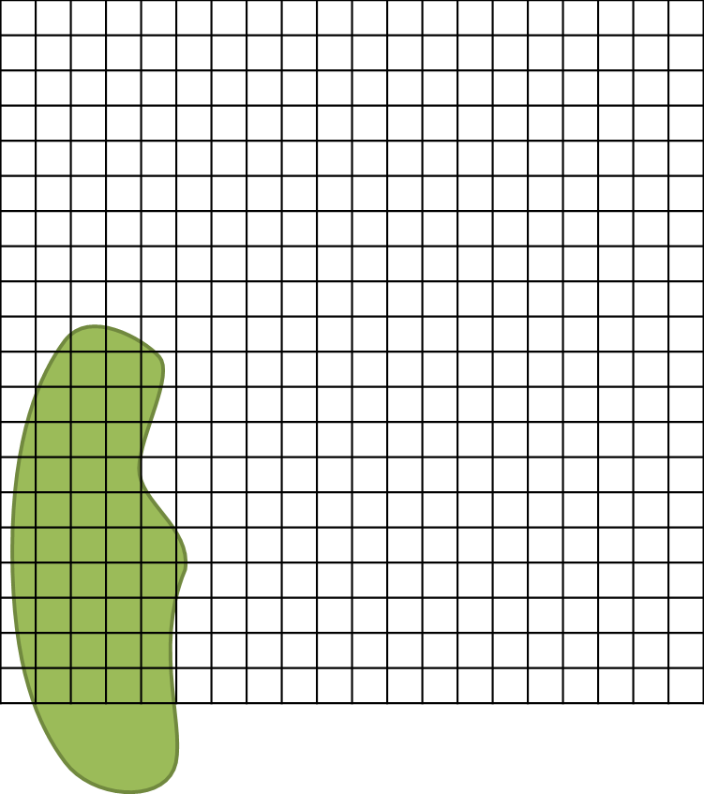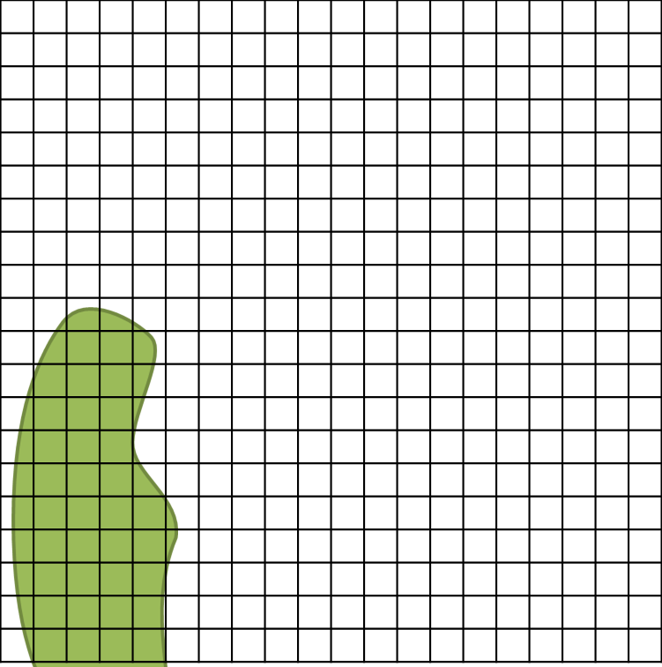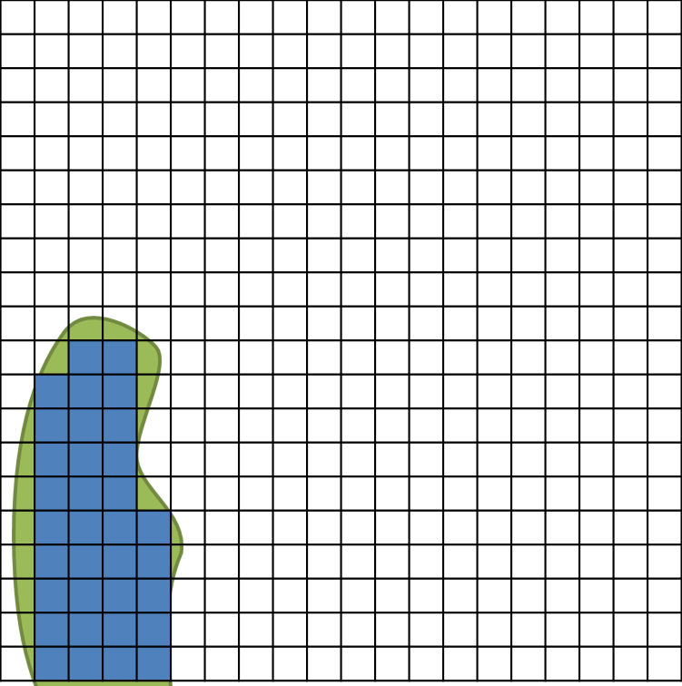

34 + ~7 = 41 m2

Step 1: Record metadata

Step 2: Draw shrub group relative to plot subplot

Step 3: Ignore portions of shrub group outside of the plot

Step 4: Count the grid cells to determine canopy area

Each group receives a unique **groupID** using the form ‘##_##’ where the first two numbers are the subplotID followed by an underscore then an incremental number (01, 02, 03…) for the plot. This number is not necessarily a permanent assignment; it is a temporary uniqueID used, in part, to group data related to multi-species groups.

**Figure 5.** Example of graph paper method for determining shrub group area within a 20 m x 20 m subplot. In this example, **canopyArea** = 41.

***For each Shrub or Liana Group:***

1. Assess the % cover of the group relative to the measurement area:

* Do not map the group if cover is 100% for a given subplot or nested subplot - i.e., stems are very dense, and a more-or-less continuous group covers the entire measurement area. When this occurs, record the nestedSubplotArea in the canopyArea field. E.g., if the nestedSubplotArea = 25 m2 and cover is 100%, record canopyArea = 25.
* If the group covers <100% of the measurement area, map the area of the group using the graph paper methods described below and shown in **Figure 5**.

1. Measure Shrub or Liana Group area with the graph paper method, and record the **canopyArea**:
   1. Label plotID, subplotID, nestedSubplotID, nestedSubplotArea on the graph paper.
   2. Draw the measurement area boundaries, (1 cm2 = 1 m2, ).
   3. Draw, to scale, the shape of the shrub group within the measurement area.
   4. Count the number of grid cells contained within the sketched group, begin with whole cells then add up partial cells: the sum is the **canopyArea** for the group.
2. Measure Shrub Group average height:
   * Use either the laser rangefinder (> 2 m), a meter tape (< 2 m) or collapsible ruler (< 2 m).
   * Record the height at 5 locations (**aGroupHeight, bGroupHeight**, etc.); nearest 0.1 m. Choose heights that you feel best represent the average maximum height of the shrub group. Bear in mind that the goal is to estimate the volume of the entire group as accurately as possible.
   * For groups that include lianas, measure height for the majority of the group, do not account for climbing stems extending to the canopy.
3. Record the % contribution by volume (ocular estimation) of each species within the shrub group (includes live + dead biomass).
4. If more than 1 species is present, record the % volume associated with each taxonID on a separate row of the datasheet, repeating the shrub **groupID** on each row. The sum of the % volume of all species present should = 100

* Do not repeat **canopyArea** or **height** measurements.
* If a taxonID is < 1% of the total shrub group volume: record %volume = 0.5

1. Record the % live and % dead for each species present. The sum of % live and % dead should = 100 for each taxonID.

Measuring ‘Other’ growth forms

**Ferns and fern allies**

Ferns and fern allies are one of the most common ‘other’ growth forms encountered across the Observatory. As a group, ferns and fern allies have a range of shapes and sizes. There are, however, a limited number of fern allometries available for estimating biomass for this group. Measurements required for common fern species are provided in Appendix F. If a fern species is not explicitly listed in Appendix F, measure according to the last row of **Table 16** (below).

***For Distributed Plots:*** Ferns may be ignored when sampling Distributed Plots if aerial cover of ferns is < 50% of the entire plot area as seen by AOP.

***For Tower Plots:*** Sampling ferns within Tower Plots is determined by Science, and is based on analysis of Site Characterization data.

*To measure Ferns and fern allies:*

1. Determine the appropriate measurement area.
   * All non-woody, ‘other’ growth forms are grouped when determining the appropriate nested subplot size. That is, if ferns are present with additional ‘other’ growth forms, the appropriate measurement area should be determined considering ferns + any additional ‘other’ growth forms.
2. Ignore all individuals with a height OR average frond length < 30 cm
   * *Note: This will likely disqualify many fern allies from consideration for this protocol*
3. Determine morphology group (see **Table 16**), and measure accordingly.

**Table 16**. Fern and fern ally morphology groups, and associated required measurements.

|  |  |
| --- | --- |
| **Morphology** | **Required measurement(s)** |
| Tree fern or similar | Height |
| Bracken Fern (*Pteridium sp.)* or similar | Basal stem diameter |
| Other fern types | Refer to Appendix F for species-specific measurements |
| ***Not listed here or in Appendix F*** | * Average frond length (select representative frond to measure) * Number of total fronds |

**Additional ‘Other’ growth forms**

‘Other’ growth forms that are also measured according to this protocol are listed below. Required measurements are unique to each growth form, and are listed in Appendix F.

* Palm trees. Distinct measurements are required for:
  + ‘shrub’-type palms (e.g., *Serenoa repens*)
  + ‘tree’-type palms (e.g., *Butia capitata*)
* Agave species
* *Cactaceae* species:
  + Not measured via this protocol.
  + Measurement of *Opuntia* species is described in the companion Cactus SOP (RD[11]).
* Yucca species
  + Include agave species with yucca-like growth form in this group.
* Xerophyllum species (i.e., Bear Grass)

###### Field Campaign Follow-up

Sample preservation

* Place plastic bags with leaf samples from unknown species in a refrigerator until they are identified and/or placed in a plant press and dried for identification at a later date.
* **Specimens should not be left in the refrigerator for more than two days.**
* Identification often requires a variety of dichotomous keys, a dissecting microscope, a dissecting kit, and a herbarium with voucher specimens for verification.

Refreshing the sampling kit

* Recharge batteries on the GPS unit.
* Make sure there are either 1) adequate supplies of fresh replacement batteries for the TruPulse 360R (type CR123A); or 2) rechargeable batteries are re-charged.
* Check that supplies of lens tissue are adequate.
* Check that supplies of consumable materials are adequate, particularly data sheets.

Equipment maintenance, cleaning, and storage

* If necessary, clean the lenses on the laser rangefinder with a lens cloth or lens tissue.
* Remove plot location information that is no longer needed from the GPS unit.

###### Data Entry and Verification

Mobile applications are the preferred mechanism for data entry. Data should be entered into the protocol-specific application as they are being collected, whenever possible, to minimize data transcription and improve data quality. Mobile devices should be synced at the end of each field day, where possible; alternatively, devices should be synced immediately upon return to the Domain Support Facility.

However, given the potential for mobile devices to fail under field conditions, it is imperative that paper datasheets are always available to record data. Paper datasheets should be carried along with the mobile devices to sampling locations at all times. As a best practice, field data collected on paper datasheets should be digitally transcribed within 7 days of collection or the end of a sampling bout (where applicable). However, given logistical constraints, the maximum timeline for entering data is within 1 month of collection or the end of a sampling bout (where applicable). See RD[04] for complete instructions regarding manual data transcription.

# References

Alves, L. F., S. A. Vieira, M. A. Scaranello, P. B. Camargo, F. A. M. Santos, C. A. Joly, and L. A. Martinelli. 2010. Forest structure and live aboveground biomass variation along an elevational gradient of tropical Atlantic moist forest (Brazil). Forest Ecology and Management **260**:679-691.

Bobich, Edward G., and Travis E. Huxman. 2009. Dry Mass Partitioning and Gas Exchange for Young Ocotillos (Fouquieria splendens) in the Sonoran Desert. International Journal of Plant Sciences **170**:283-289.

Gerwing, J. J., S. A. Schnitzer, R. J. Burnham, F. Bongers, J. Chave, S. J. DeWalt, C. E. N. Ewango, R. Foster, D. Kenfack, M. Martínez-Ramos, M. Parren, N. Parthasarathy, D. R. Pérez-Salicrup, F. E. Putz, and D. W. Thomas. 2006. A standard protocol for liana censuses. Biotropica **38**:256-261.

Gholz, H. L., C. C. Grier, A. G. Campbell, and A. T. Brown. 1979. Equations for estimating biomass and leaf area of plants in the Pacific Northwest. Oregon State University, Forest Research Lab, Corvallis, OR.

Jenkins, J. C., D. C. Chojnacky, L. S. Heath, and R. A. Birdsey. 2003. National-scale biomass estimators for United States tree species. Forest Science **49**:12-35.

Jenkins, J. C., D. C. Chojnacky, L. S. Heath, and R. A. Birdsey. 2004. Comprehensive database of diameter-based biomass regressions for North American tree species. USDA Forest Service **GTR-NE-319**:1-45.

Ludwig, J. A., J. F. Reynolds, and P. D. Whitson. 1975. Size-biomass relationships of several Chihuahuan Desert shrubs. American Midland Naturalist **94**:451-461.

Lutz, J. A., K. A. Schwindt, T. J. Furniss, J. A. Freund, M. E. Swanson, K. I. Hogan, G. E. Kenagy, and A. J. Larson. 2014. Community composition and allometry of Leucothoe davisiae, Cornus sericea, and Chrysolepis sempervirens. Canadian Journal of Forest Research **44**:677-683.

Morel, A. C., S. S. Saatchi, Y. Malhi, N. J. Berry, L. Banin, D. Burslem, R. Nilus, and R. C. Ong. 2011. Estimating aboveground biomass in forest and oil palm plantation in Sabah, Malaysian Borneo using ALOS PALSAR data. Forest Ecology and Management **262**:1786-1798.

Schafer, J. L., and M. C. Mack. 2014. Growth, Biomass, and Allometry of Resprouting Shrubs after Fire in Scrubby Flatwoods. The American Midland Naturalist **172**:266-284.

Schnitzer, S. A., S. Rutishauser, and S. Aguilar. 2008. Supplemental protocol for liana censuses. Forest Ecology and Management **255**:1044-1049.

U.S. Forest Service. 2012. Forest Inventory and Analysis National Core Field Guide. Volume I: Field Data Collection Procedures for Phase 2 Plots. **Volume I**:1-427.

Datasheets

The following datasheets are associated with this protocol:

**Table 17.** Datasheets associated with this protocol.

|  |  |
| --- | --- |
| **NEON Doc. #** | **Title** |
| NEON.DOC.001573 | Datasheets for TOS Protocol and Procedure: Measurement of Vegetation Structure |
|  |  |

These datasheets can be found in Agile or the NEON Document Warehouse.

Quick References

Quick Reference: Making Quality Measurements of Woody Vegetation Structure

**Step 1** – Calibrate laser rangefinder compass.

**Step 2** – Delineate measurement area.

**Step 3** – Assess need for subplots (typically for new plots only).

**Step 4** – Tag and identify species of each qualifying individual (new plots and as needed in existing plots). See summary tables on next page for location and method of tagging.

**Step 5** – Record metadata on data sheets (Plot ID, Subplot # and nestedSubplotSize).

**Step 6** – Take and record measurements

**Step 7** – Remove temporary flagging.

For directions on using the laser rangefinder, see TOS Standard Operating Procedure: TruPulse Rangefinder Use and Calibration (RD[09]).

Reminders

**Making quality measurements of vegetation structure**

**Measurement Area**: Make sure to know…

* Size of plot and subplots.
* Number of subplots in the plot.
* Size of nested subplots (if any) for plots previously measured.
* How to determine whether nested subplots are needed for new plots.

**Taking Measurements**: Remember to…

* Include stem in tally if > 50% of the individual (or > 50% of stems for multi-stemmed plants) are rooted in the measurement area.
* Use temporary flagging to distinguish measured and unmeasured stems.
* Carefully record all metadata, measurements, and observations on data sheet.
* Mark, map, and tag new individuals that meet minimum size cutoff.
* Identify previously tagged stems that have died since last measurement.
* Remove temporary flagging when measurements are completed

**Using the laser rangefinder**: Pay close attention to…

* Declination – Is it set for your current location?
* Selection choices in drop-down menu.
* Battery charge – Replace when low-charge indicated.
* Transcription of measurements onto data sheet.
* Metal objects – Keep them at least 2 feet away from instrument when using internal compass.

Directions for the laser rangefinder are in TOS Standard Operating Procedure: TruPulse Rangefinder Use and Calibration (RD[09]).

Woody Stem Measurement Guidelines

In the sections below, guidelines for tree measurement were adapted from the U.S. Forest Service Forest Inventory and Analysis National Core Field Guide (U.S. Forest Service 2012). The approach for measuring shrubs was developed in collaboration with researchers from the Smithsonian “Mega-Plot” network (SIGEO)(Lutz et al. 2014).

Irregular Boles

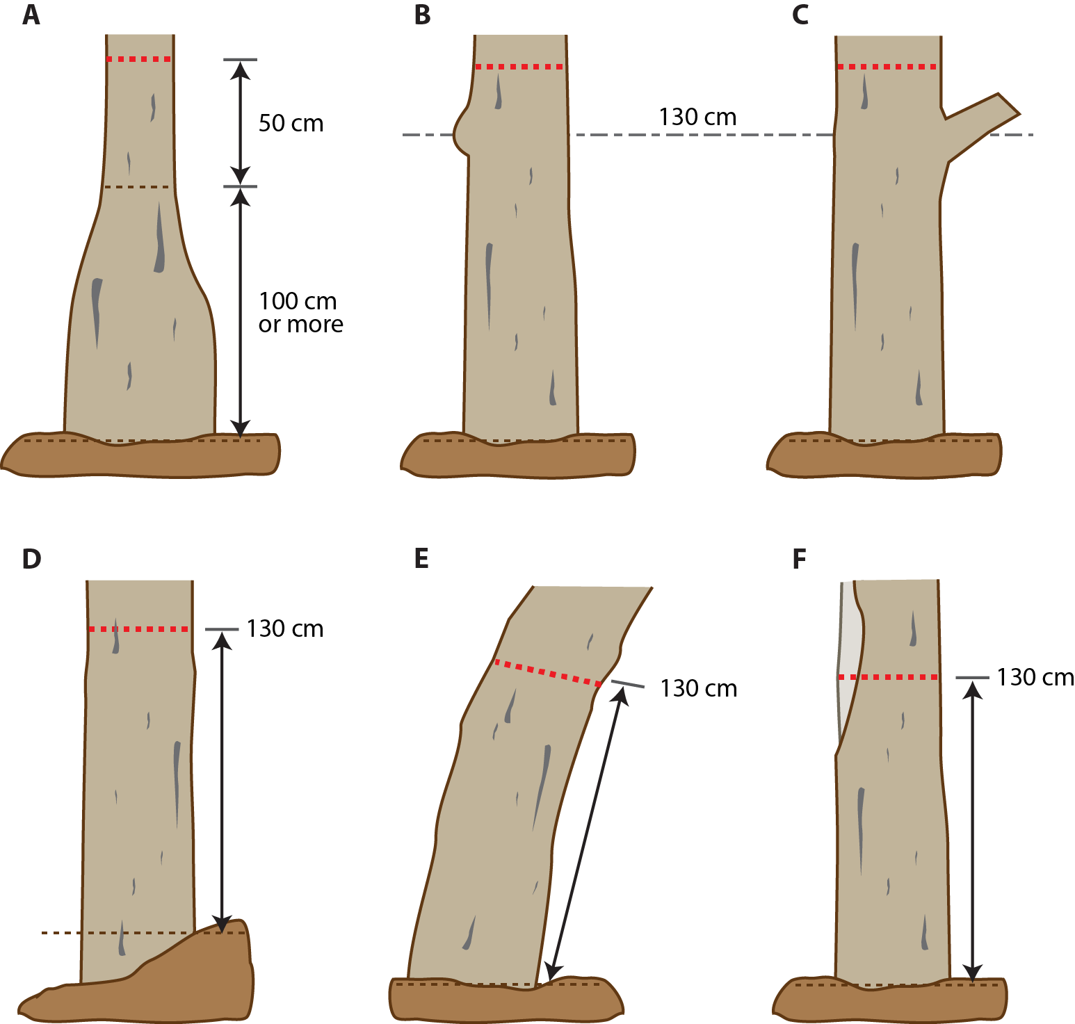

The lowest dashed line represents ground level from which the desired measurement height is referenced. The thick dashed red line shows the desired measurement height above ground level. Place tags 10 cm above the measurement height.

1. ***Pronounced thickening near the base.*** If the point at which swelling returns to normal is ≥ 100 cm above the ground (top dashed line), **measurementHeight** for bole diameter is 50 cm above this point.
2. ***Irregularities at breast height.*** If swelling, bumps, depressions or other irregularities occur at breast height, move the measurementHeight above the irregularity to a point where the bole becomes regular again.
3. ***Branches at breast height.*** Similar to **(B)**, move the measurementHeight above the branch to a point where the branch no longer affects bole diameter and the bole is “regular.”
4. ***Sloped ground.*** Consider ground level to be the uphill side of the bole, and measure DBH 130 cm above this point.
5. ***Leaning tree.*** Measure diameter 130 cm along the bole on the underside face. If a tree grows on a slope and leans downhill, this rule is waived in favor of **(D)** above.
6. ***Missing wood or bark.*** If a tree is missing substantial wood or bark at the desired measurementHeight (light grey indicates exposed wood and missing bark), do not attempt to reconstruct the diameter as it would appear without the damage. Measure the DBH of the wood and bark that is present. However, if the damage is localized, treat it as an irregularity, and measure as in **(B)**.

Multi-bole Individuals and Stem Diameter Measurement

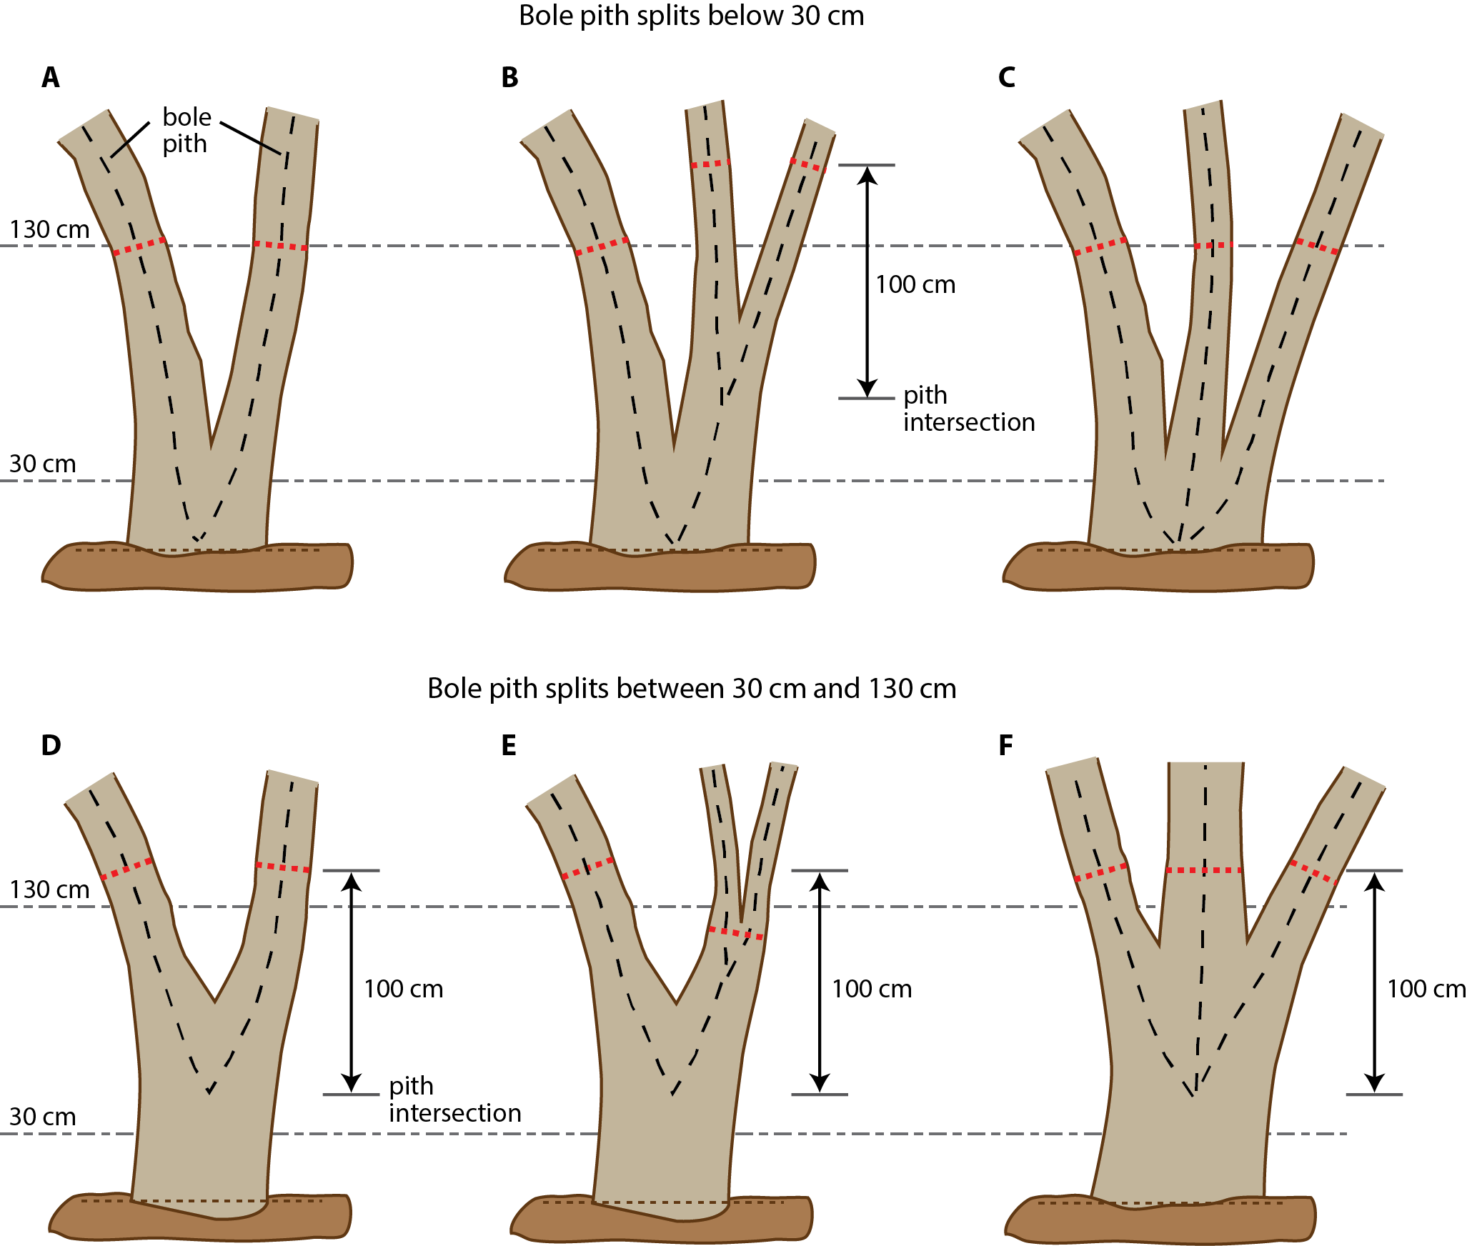

In the figure above, all individuals are either ‘mbt’ or multi-bole ‘smt’ growthForms. Furthermore:

* The lowest, finely dashed line represents ground level from which the 30 cm and 130 cm reference heights are drawn (multi-dashed background lines).
* The thick dashed red line shows the desired measurement height above ground level.
* If the bole is not growing vertically, measure 130 cm along the bole, rather than 130 cm above ground. Diameter is measured perpendicular to the pith.
* Large dashed black lines indicate the pith of each bole.
* Tag 10 cm above the measurementHeight.
* To qualify as a split, or fork, the stem in question must be at least **⅓** the diameter of the main bole, and must branch out from the main bole at an angle of < 45˚.
  + ***Exception:*** Forks that are < 2.5 cm diameter are ignored and NOT measured, even if they meet the ⅓ diameter requirement. This exception holds for ‘mbt’ and multi-bole ‘smt’ individuals.
* Forks originate at the point on the bole at which the piths intersect.

1. ***Simple split***. Piths intersect ≤ 30 cm above the ground. Measure stemDiameter on each bole 130 cm above the ground, or 130 cm along the stem if curved.
2. ***Compound split.*** Primary piths intersect ≤ 30 cm above the ground. Because each of the two main boles are measured separately, stemDiameter on the left bole is measured 130 cm above the ground. However, the right bole forms a secondary split between 30 cm and 130 cm. Here, the stemDiameter of the secondary splits are measured 100 cm above the point of the secondary pith intersection.

In the event the pith intersection for the secondary fork on the right occurs close to 130 cm, the resulting desired measurement location may be out of reach for all but the tallest foresters. Adjust the measurementHeight downward, if necessary, to ensure that repeat measurements can be made by the average person. Repeatability through time is more important that reaching exactly 100 cm above the fork in the pith.

1. ***Multiple boles.*** Multiple piths originate from the same point ≤ 30 cm above the ground. Measure stemDiameter on each bole 130 cm above the ground, or 130 cm along the stem if curved.
2. ***Elevated simple split.*** Simple split with piths intersecting > 30 cm and ≤ 130 cm above the ground. Forks originating between 30 cm and 130 cm are measured 100 cm above the pith intersection point.
3. ***Elevated compound split.*** Primary piths intersect > 30 cm and ≤ 130 cm above the ground. The left primary fork is assessed independently from the right one. On the left, stemDiameter is measured 100 cm above the primary pith intersection point. The right bole forms a secondary split between 30 cm and 130 cm; in this case, once a stem is tallied as a fork originating from a primary split between 30 cm and 130 cm, ignore any additional forks, and measure just below the base of stem separation. That is, do not measure stemDiameter the full 100 cm above the primary pith intersection point.
4. ***Elevated multiple boles.*** Multiple piths originate from the same point > 30 cm and ≤ 130 cm above the ground. To qualify, multiple boles must originate from roughly the same point along the main bole. Each bole is assessed as an independent tree, and stemDiameter is measured 100 cm above the pith intersection point.

Live Downed Trees

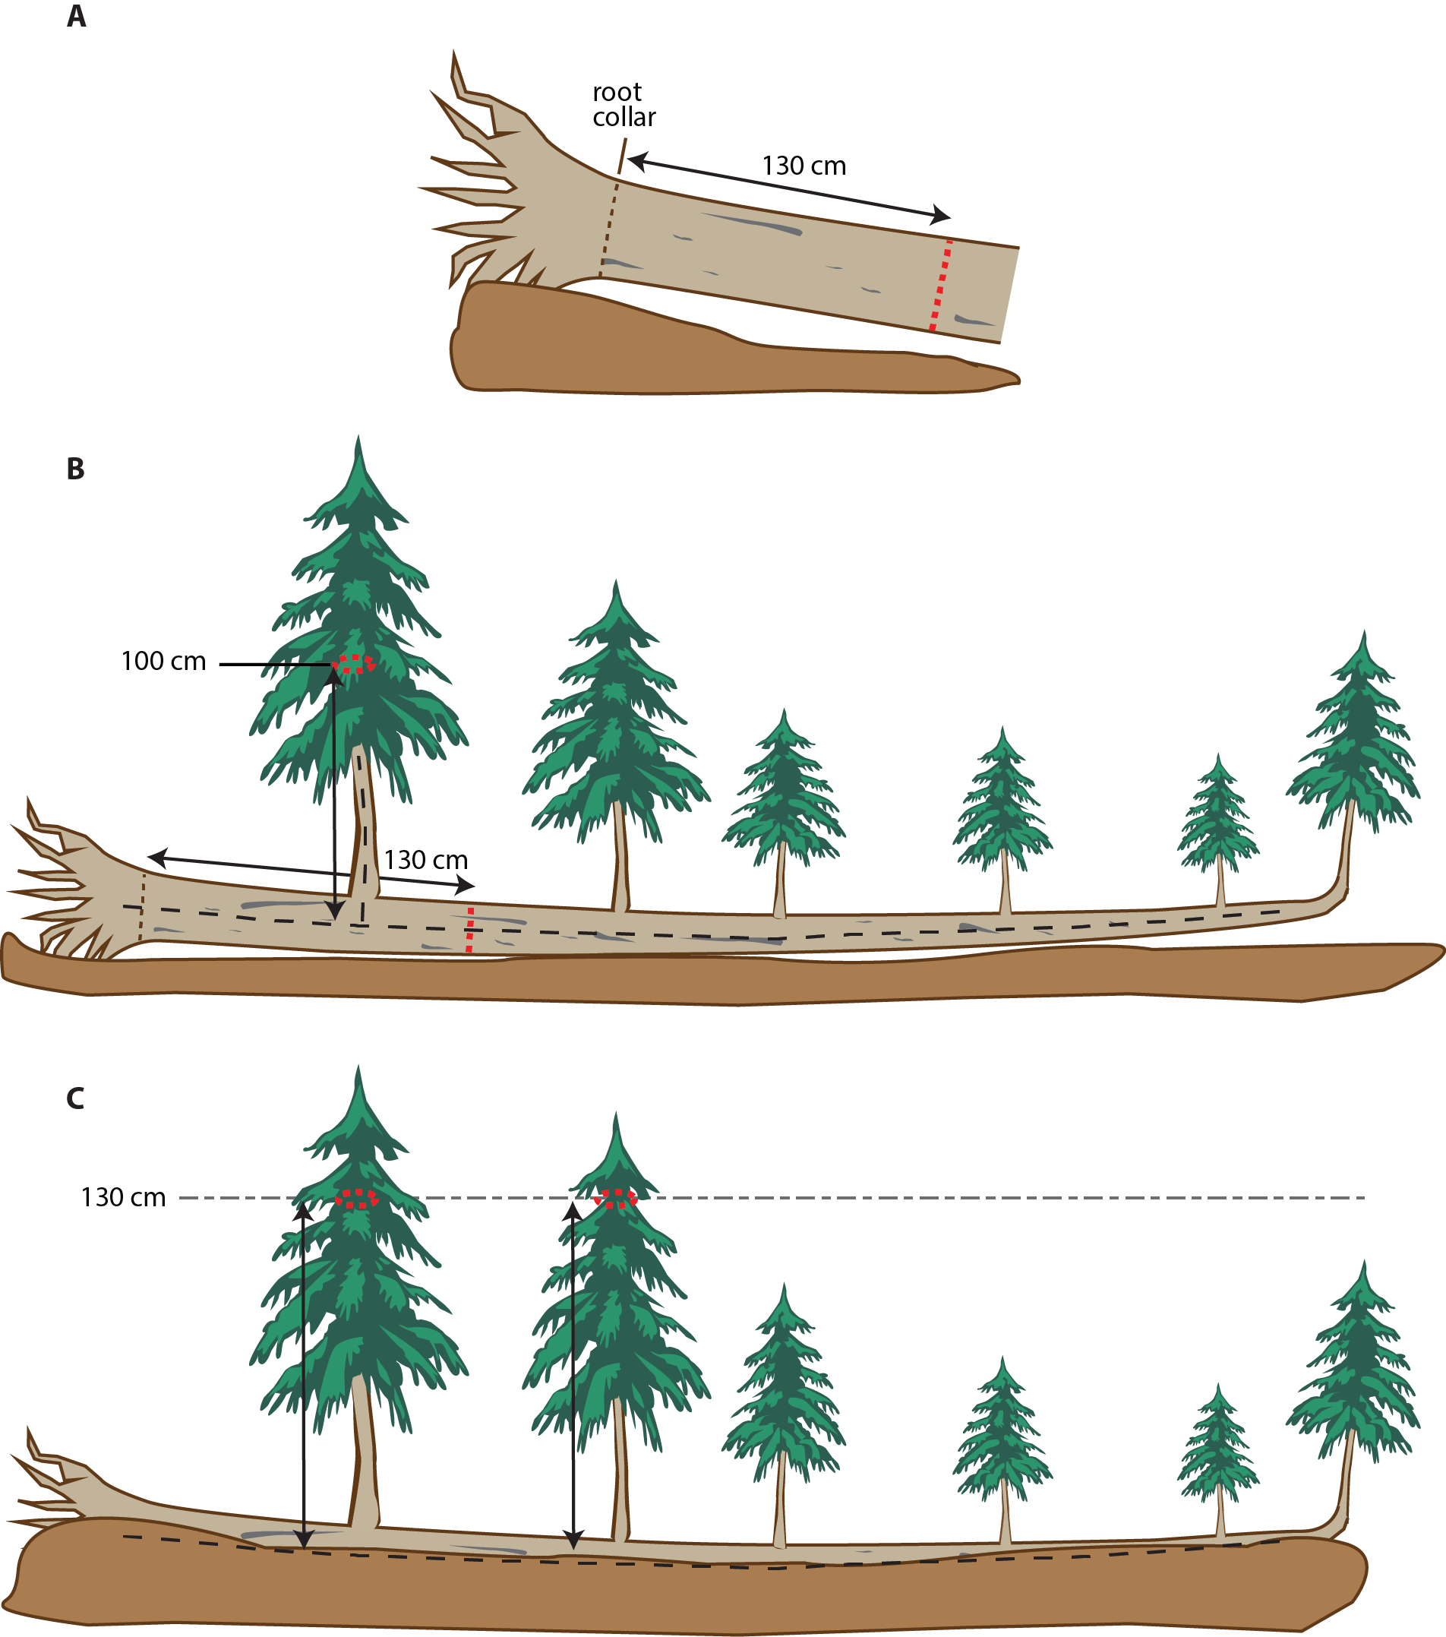

1. ***Live windthrown tree.*** Measure 130 cm along the bole from the top of the root collar. Tag 10 cm above the measurement location.

For **(B)** and **(C)**, consider a downed live tree, touching the ground, with tree-like branches that originate from the main bole, AND are less than 45˚ off the vertical. If the pith of the main bole (black dashed line) is above the duff layer, assess according to **(B)**, and if the pith is below the duff layer, assess according to **(C)**.

1. ***Pith above duff.*** Use the same forking rules specified for a forked tree, and measure and tag accordingly. If the intersection between the main downed bole and the tree-like branch is > 130 cm along the main bole, treat that branch as part of main bole – i.e., ignore it.
2. ***Pith below duff.*** Ignore the main bole of the tree, and assess each tree-like branch individually to determine whether it qualifies for measurement. In the figure, the two left-most tree-like branches are ≥ 10 cm DBH, and are measured 130 cm above the ground (not necessarily equal to measuring from the top of the main downed bole). The other, smaller tree-like branches may qualify for measurement if they lie within the desired measurement area (i.e., nested subplot size).

Mixed Status Individuals

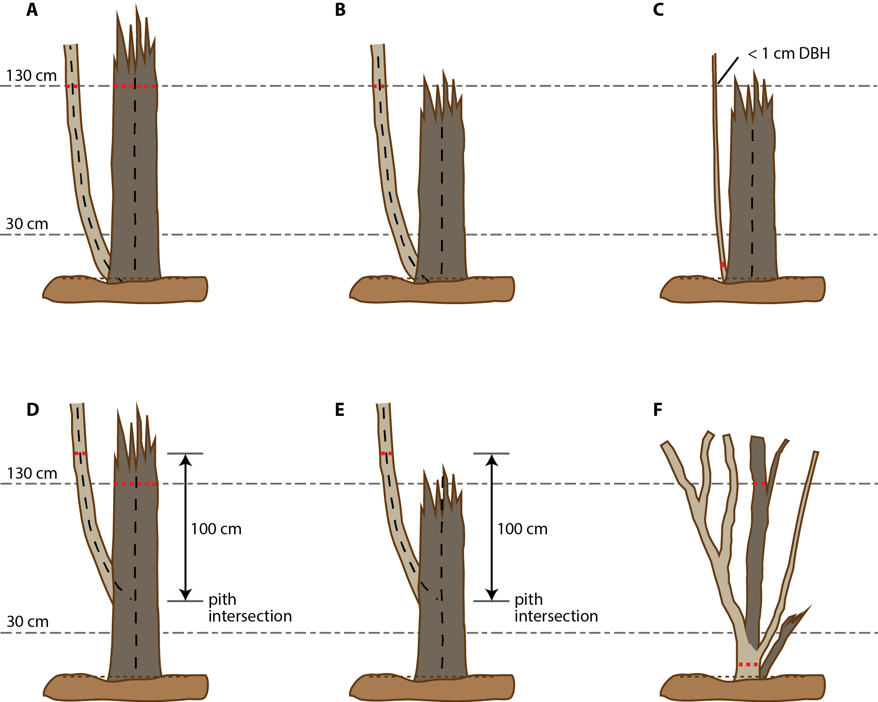

The figure above deals with trees **(A – E)** and shrubs **(F)** that have both living (light brown) and dead (dark brown) boles or portions of stems. The lowest, finely dashed line represents ground level from which the desired measurement height is referenced. The thick dashed red line shows the stemDiameter measurement location. For **(A – E):**

* Stump sprouts originate between ground level and 130 cm above the ground.
* Measure stump sprouts the required distance along the bole if it is growing off the vertical.
* Stump sprouts are handled the same as forked trees, with the exception that the diameter of the sprout is **NOT** required to be ⅓ the diameter of the main bole, and there is no 2.5 cm minimum diameter.
* For multi-stemmed woodland species, treat all new sprouts as part of the same new tree.

1. ***Resprout with dead main bole that is > 130 cm height.*** The pith of the resprout intersects with the main dead bole somewhere below the ground. Growth form is a multi-bole tree (mbt). Similar to when both boles are alive, measure the diameter of each bole 130 cm above the ground. For the dead bole on the right, measure the diameter of the break point as well as DBH, and also record the height of the break point.
2. ***Resprout ≥ 1 cm DBH with dead main bole that is < 130 cm height.*** Measure the DBH of the resprout 130 cm above the ground, and ignore the dead main bole. The diameter of the resprout determines the growth form (sbt or smt); if growthForm = smt, only measure if the individual falls within the desired measurement area.
3. ***Resprout < 1 cm DBH with dead main bole that is < 130 cm height.*** Measure the diameter of the resprout 10 cm above the ground (ddh), and ignore the dead main bole. The growthForm = sap, and the individual is only measured if it falls within the desired measurement area. If the main dead bole is > 130 cm height as in **(A)**, then measure the dead bole as in **(A)**.
4. ***Resprout ≥ 1 cm DBH with pith intersecting that of the main bole between 30 cm – 130 cm above the ground.*** Growth form is a multi-bole tree (mbt). Similar to when both boles are alive, measure the diameter of the resprout 100 cm above the pith intersection point. Measure the dead bole as in **(A)**.
5. ***Resprout ≥ 1 cm DBH with pith intersecting main dead bole ≥ 30 cm above the ground, and the latter is < 130 cm height.*** Measure the DBH of the resprout 100 cm above the pith intersection point, and ignore the main dead bole. The growthForm = sbt or smt.
6. ***Shrub with plantStatus = dead for largest split, and broken dead stems.*** plantStatus = live for the entire individual, even though the largest split is dead. If the individual has multiple qualifying emergent stems > 130 cm height (or total length) with different status, DO record status separately for each emergent stem. Measure DBH at 130 cm on largest split, and measure ddh. Ignore broken dead emergent stems that are < 130 cm height (or total length if growing off the vertical).

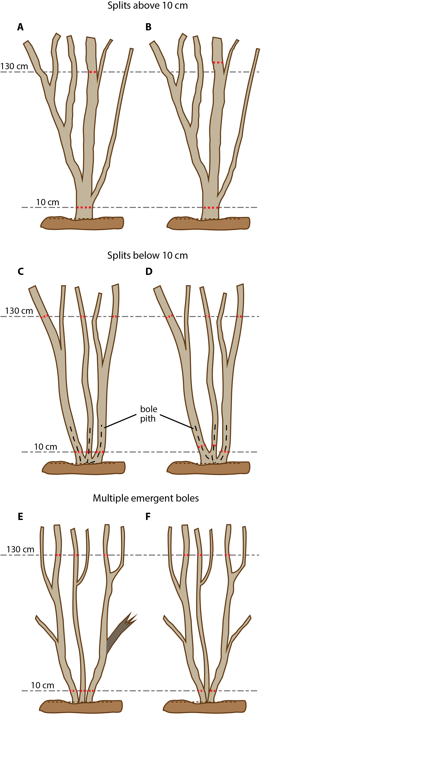Shrubs

The brown dashed line represents ground level. The thick dashed red line shows the desired stemDiameter measurement height above ground level. Simple dashed black lines represent stem piths. Light brown shows live tissue, and dark brown indicates dead.

1. ***Simple shrub with unified base.*** Measure DBH at 130 cm (or along the pith for decumbent growth forms) on *the thickest fork only*, and measure diameter at decimeter height (ddh).
2. ***Irregular at DBH.*** Similar to **(A)**, but with a branch point at 130 cm on the largest fork. Move the measurement height up on the largest fork so the DBH is not influenced by the branch. Measure ddh as in **(A)**.
3. ***Multiple stems connected above ground.*** Piths intersect below 10 cm and originate from a visible root collar. Consider emergent boles separately for stemDiameter, and intact boles together for crown diameter(s). Measure DBH at 130 cm *on the thickest fork only,* and measure ddh for each emergent bole with qualifying DBH.
4. ***Irregular at ddh.*** Similar to **(C)**, but the base of stem separation for the left two stems occurs right at 10 cm above ground. Because the piths intersect below 10 cm, the left two stems are still considered separately, but the stemDiameter is measured higher where the diameters are not affected by the fork.
5. ***Multiple stems connected below ground.*** If boles emerge independently from a buried root collar, consider each emergent bole separately for stemDiameter. Measure DBH *on the thickest fork at 130 cm height;* the thickest fork on the right stem is dead/broken and ignored because it does not reach 130 cm. Measure ddh for each emergent bole with qualifying DBH.
6. ***Access denied.*** Similar to **(E)**, but desired measurement height on middle emergent bole is not accessible. For the middle bole, the ddh is not measured if a measurement location cannot be accessed within the first 30 cm along the stem.

Saplings and Small Shrubs

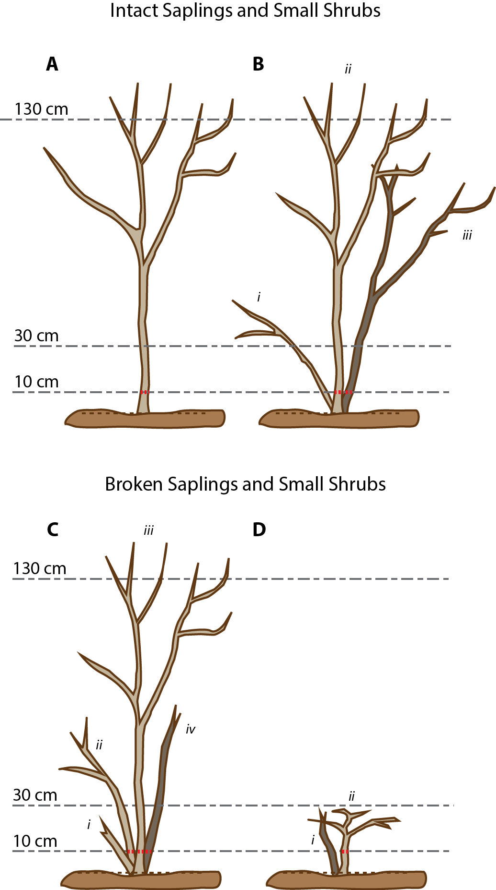Saplings and small shrubs have no qualifying DBH. The brown dashed line represents ground level. The dashed red line shows the stemDiameter measurement height relative to ground. Light brown shows live, and dark brown indicates dead. For all cases, consider emergent stems separately for basal stem diameter measurements, and consider all intact stems together when measuring crown diameter(s).

1. ***Simple sapling or small shrub with unified base.*** Measure ddh 10 cm above the ground, or 10 cm along the stem for decumbent growth forms.
2. ***Multiple intact stems connected below ground.*** *(i)* Ignored: ddh < 1 cm; *(ii)* Measure ddh, plantStatus = live; *(iii)* Measure ddh, plantStatus = dead.
3. ***Multiple intact and broken stems, connected below ground.*** *(i)* Ignored: ddh ≥ 1 cm, but broken, and total length < 30 cm; *(ii)* Measure ddh, plantStatus = live; *(iii)* Measure ddh, plantStatus = live; *(iv)* Measure ddh: broken, but total length ≥ 30 cm, plantStatus = dead.
4. **Mixed status dwarf small shrub.** *(i)* Ignored: ddh ≥ 1 cm, but broken, and total length < 30 cm; *(ii)* Measure ddh for live stems < 30 cm length if stem meets qualifying diameter and is not broken.

Liana Measurement Guidelines

The guidelines below ensure consistent measurement of complex liana growth forms (adapted from Schnitzer et al. 2008). Although originally conceived with respect to lianas, these guidelines should also be used to consistently determine the measurement location for other types of woody stems that are similarly complex.

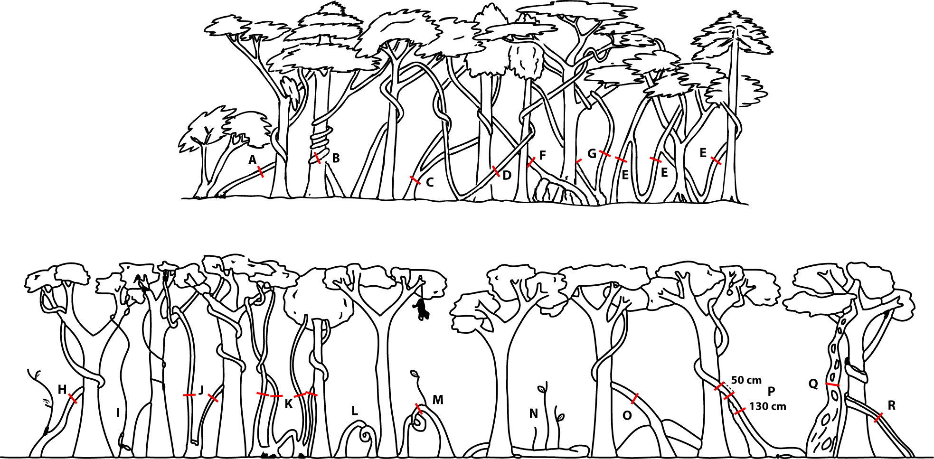

**Figure 6**. Guidelines for determining where to measure liana stem diameter (red line) across a variety of complex growth forms. Different growth forms correspond to capital letters, and are described more fully below. Cases A-G (top panel) are commonly encountered, and cases H-R (bottom panel) are less common.

1. Individuals that simply ascend into the canopy are measured 130 cm along the stem from the main rooting point.
2. Twining individuals are measured 130 cm along the stem from the rooting point, including all twists and curves.
3. Individuals that split below 130 cm from the rooting point are measured 20 cm below the branching point:
   1. If the branch point is less than 40 cm from the ground, measure half-way between the branch point and the ground, where the stem is regular.
   2. If the stem is not regular anywhere between the branch point and the ground, measure according to **(G)** below.
4. Individuals that loop to the ground and root again before ascending to the canopy are measured 130 cm from the last rooting point.
5. Like **(D)**, but the loops have branches that ascend to the canopy. Each rooted ascending stem with a leafy canopy branch is recorded separately as part of a multi-bole individual.
6. Individuals with rooted adventitious roots further than 80 cm from the main rooting point are measured 50 cm past the last root.
7. Individuals that branch below 130 cm, but have a very irregular main stem or branch close to the ground. Measure branches separately at 130 cm, and record as part of a multi-bole individual.
8. Ignore branches < 1 cm diameter, and measure the principal stem 130 cm from the roots.
9. Exclude individuals that branch below 130 cm from the roots if none of the stems are ≥ 1 cm diameter at 130 cm above the roots.
10. Similar to **(G)** above.
11. Multiple rooting points in a small area: Measure each branch ≥ 1 cm diameter 130 cm from the roots of the most proximal rooting point.
12. Exclude “ground-to-ground” individuals that loop from one rooting point to another and do not ascend to the canopy. Also exclude those individuals that are prostrate on the soil, even if they are ≥ 1 cm in diameter.
13. Include “ground-to-ground” individuals if they have a resprout or branch, even if the branch is < 1 cm diameter. If the branch is < 1 cm, measure the principal stem 130 cm from the roots, ignoring the branch. If the branch is ≥ 1 cm diameter, and within 130 cm of the roots, the point of measurement should be on the ascending branch.
14. Exclude individuals growing prostrate on the soil if they do not have a stem ≥ 1 cm diameter ascending towards the canopy.
15. Exclude multiple branches that originate within 130 cm of the main roots if they are smaller than 1 cm diameter.
16. Measure 50 cm above the last aerial root if that root attaches to the principal stem > 80 cm above where the principal stem is rooted in the soil.
17. If the stem is anomalous and not uniform below 130 cm from the root, measure 20 cm above the point where it becomes uniform; if there is no uniform area within reach, measure the stem 130 cm from the roots.
18. If the stem is flat and wide, include the individual if the mean of its wide and narrow axes is ≥ 1 cm diameter.

Guidelines for measuring ‘Other’ Vegetation

|  |  |  |  |  |  |  |  |  |
| --- | --- | --- | --- | --- | --- | --- | --- | --- |
| **Growth Form** | **taxonID** | **leaf/stem**  **Number** | **maxCrown**  **Diameter** | **ninetyCrown**  **Diameter** | **height** | **stemDiameter** | **meanLeafLength** | **Reference** |
| **Ferns1 (frn)** | *Athyrium filix-femina* | leaf |  |  |  |  | x | Gholz et al. (1979) |
|  | *Blechnum spicant* | leaf |  |  |  |  | x | Gholz et al. (1979) |
|  | *Dryopteris austriaca* | leaf |  |  |  |  | x | Gholz et al. (1979) |
|  | *Polystichum munitum* | leaf |  |  |  |  | x | Gholz et al. (1979) |
|  | *Pteridium aquilinum* |  |  |  |  | basal |  | Gholz et al. (1979) |
|  | *Cyathea sp.* |  |  |  | x |  |  | Alves et al. (2010) |
| **Palms (plm)** | *Serenoa repens* | leaf | x | x | x |  |  | Schafer and Mack (2014) |
|  | *Sabal etonia* | leaf | x | x | x |  |  | Schafer and Mack (2014) |
|  | *Arecaceae spp. (i.e., tree palms)* |  |  |  | x | DBH |  | Morel et al. (2011) |
| *Agave sp.* (agv) | |  | x | x | x |  |  |  |
| *Fouquieria splendens –* Ocotillo  (oco) | | stem | basal | basal | x |  |  | Bobich and Huxman (2009) |
| *Xerophyllum tenax –* Bear Grass(xer) | |  |  |  |  | basal | x | Gholz et al. (1979) |
| *Yucca sp.* (yuc)  *Includes agave and other species with yucca-like, large basal rosette growth form* | |  | x | x | x |  |  |  |

1 Fern species not mentioned in this table should be measured similarly to *Athyrium filix-femina.* In order to qualify for measurement according to this protocol, ferns must have an average frond length ≥ 30 cm.

Plot Map

Plot pointIDs are numbered according to the largest possible plot size, 80 m x 80 m, such that a plot of any size will use a consistent numbering scheme. A pointID is defined for every point on a 10 m grid within this framework; this design is used in initial plot establishment, but permanent, primary, and secondary markers are placed at 20 meter intervals. During stem mapping, technicians will only use the points that have permanent markers in place. Plot subplotIDs are determined by the pointID of the SW corner of the subplot area. Plot center will always be pointID 41.

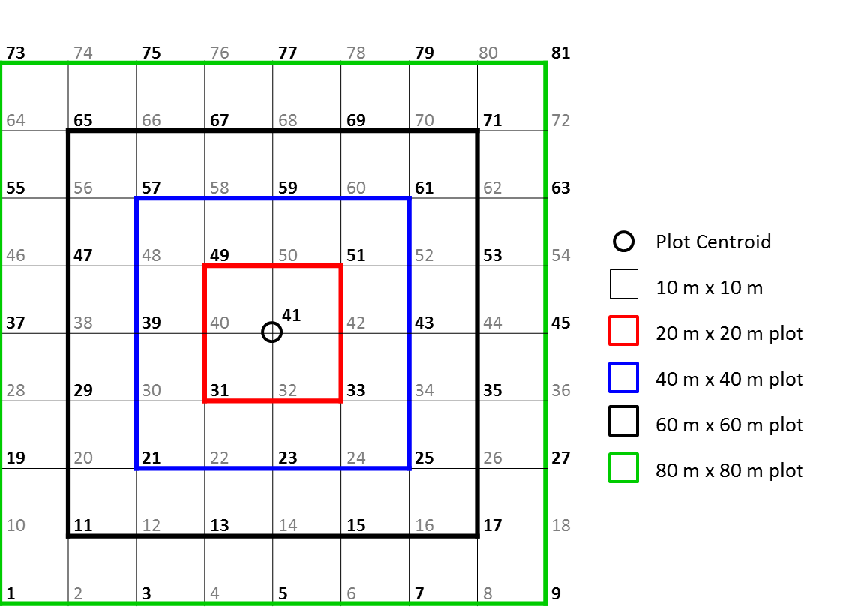

**Figure 7.** Plot map, illustrating how NEON base plots of various sizes are constructed from 10 m x 10 m ‘modules.’ The SW corner of each ‘module’ receives a pointID number; bold numbers indicate pointIDs that may receive physical markers and for which high-resolution GPS data may be collected.

Estimated Dates for Onset and Cessation of Sampling

The dates in **Table 18** below are based on historic records, and are therefore estimates for the average start and stop dates of sampling. It is essential that domain staff monitor real-time conditions to determine when to start (and stop) sampling, as described in Section 4 of this protocol.

***“Start Date” definition:*** Below, values in the “Start Date” field correspond to the average day of year at which greenness begins to decrease. Use these dates as a guide for when to begin monitoring for senescence. The goal is to begin vegetation structure sampling when approximately 50% of deciduous woody plants and/or herbaceous plants have begun to senesce.

“Start Date” and “End Date” fields are relevant to vegetation structure measurement windows in both Distributed and Tower plots, and represent the period of time during which vegetation photosynthetic activity is minimal following a growing season. The “Protocol Implementation” field indicates qualifying vegetation is present based on satellite imagery and on-the-ground feedback in a given plot type at the site level, and therefore the Vegetation Structure protocol should be implemented. If you feel this assessment is inaccurate for your site, please submit a problem ticket to Science Operations. It will not necessarily be possible to record vegetation structure data throughout the entire measurement window, due to snow, site access issues, etc. If provided measurement windows are not logistically feasible, changes to “Start Date” may be made in consultation with Science Operations.

All dates in **Table 18** are estimated from MODIS-EVI phenology data averaged from 2001-2009. Unless indicated otherwise, “End Date” values are in the next calendar year.

**Table 18.** Site-specific sampling start and end dates for vegetation structure measurements

| **Domain Number** | **Site ID** | **Start Date** | **End Date** | **Protocol Implementation by Plot Type** | **Additional Sampling Information** |
| --- | --- | --- | --- | --- | --- |
| 01 | BART | 08/08 | 04/30 | Dist = Yes  Tower = Yes | Access problems may exist during proposed measurement window. |
| HARV | 08/08 | 04/20 | Dist = Yes  Tower = Yes | Access problems may exist during proposed measurement window. |
| 02 | BLAN | 07/29 | 03/16 | Dist = Yes  Tower = Yes |  |
| SCBI | 08/08 | 03/26 | Dist = Yes  Tower = Yes |  |
| SERC | 08/08 | 03/21 | Dist = Yes  Tower = Yes |  |
| 03 | DSNY | 07/09 | 03/01 | Dist = Yes  Tower = No |  |
| JERC | 08/08 | 03/31 | Dist = Yes  Tower = Yes |  |
| OSBS | 07/09 | 03/11 | Dist = Yes  Tower = Yes | Not all Distributed plots may have qualifying stems. |
| 04 | GUAN | 12/01 | 03/01 | Dist = Yes  Tower = Yes | Dates correspond to the dry season, and are derived from Ensenada precipitation data (1980-2015). |
| LAJA | 12/01 | 03/01 | Dist = Yes  Tower = Yes | Dates correspond to the dry season, and are derived from Ensenada precipitation data (1980-2015). |
| 05 | STEI | 08/03 | 04/30 | Dist = Yes  Tower = Yes | Not all Tower plots may have qualifying stems. |
| TREE | 08/03 | 04/30 | Dist = Yes  Tower = Yes |  |
| UNDE | 08/03 | 05/05 | Dist = Yes  Tower = Yes |  |
| 06 | KONA | NA | NA | Dist = No  Tower = No |  |
| KONZ | 07/29 | 03/31 | Dist = Yes  Tower = Yes | Isolated stems may be encountered in Distributed plots. |
| UKFS | 07/29 | 03/16 | Dist = Yes  Tower = Yes |  |
| 07 | GRSM | 08/03 | 03/31 | Dist = Yes  Tower = Yes |  |
| MLBS | 08/08 | 04/20 | Dist = Yes  Tower = Yes |  |
| ORNL | 07/29 | 03/31 | Dist = Yes  Tower = Yes |  |
| 08 | DELA | 07/24 | 03/01 | Dist = Yes  Tower = Yes |  |
| LENO | 07/19 | 03/11 | Dist = Yes  Tower = Yes |  |
| TALL | 07/14 | 03/16 | Dist = Yes  Tower = Yes |  |
| 09 | DCFS | 07/24 | 04/30 | Dist = Yes  Tower = Yes | Isolated stems may be encountered in Distributed plots. |
| NOGP | 07/19 | 04/25 | Dist = Yes  Tower = No | Isolated stems may be encountered in Distributed plots. |
| WOOD | 07/29 | 04/30 | Dist = Yes  Tower = No | Isolated stems may be encountered in Distributed plots. Initial survey of Tower Plots 🡪 6% woody veg cover; vst sampling not required. |
| 10 | CPER | 07/29 | 03/31 | Dist = Yes  Tower = Yes | Isolated stems may be encountered in Distributed plots; Cactus SOP required for Tower Plots. |
| RMNP | 07/29 | 04/30 | Dist = Yes  Tower = Yes |  |
| STER | NA | NA | Dist = No  Tower = No |  |
| 11 | CLBJ |  |  | Dist = Yes  Tower = Yes |  |
| OAES | NA | NA | Dist = No  Tower = No |  |
| 12 | YELL | 07/09 | 04/30 | Dist = Yes  Tower = Yes | Access problems may exist during proposed measurement window. |
| 13 | MOAB | 08/13 | 03/26 | Dist = Yes  Tower = Yes | Short shrubs, widely spaced; many may not be qualifying stems. |
| NIWO | 08/08 | 05/20 | Dist = Yes  Tower = Yes | Access problems may exist during proposed measurement window. |
| 14 | JORN | 09/02 | 03/21 | Dist = Yes  Tower = Yes |  |
| SRER | 08/28 | 05/31 | Dist = Yes  Tower = Yes |  |
| 15 | ONAQ | 06/19 | 03/16 | Dist = Yes  Tower = Yes |  |
| 16 | ABBY | 07/24 | 04/20 | Dist = Yes  Tower = Yes | Not all plots may have qualifying stems. |
| WREF | 07/29 | 04/25 | Dist = Yes  Tower = Yes |  |
| 17 | SJER | 04/05 | 09/27 | Dist = Yes  Tower = Yes |  |
| SOAP | 07/04 | 03/31 | Dist = Yes  Tower = Yes |  |
| TEAK | 07/24 | 04/30 | Dist = Yes  Tower = Yes | Access problems may exist during proposed measurement window. |
| 18 | BARO | 07/29 | TBD | Dist = No  Tower = No | Isolated qualifying stems may exist. |
| TOOL | 07/24 | 06/09 | Dist = Yes  Tower = No | Tower Plots: Abundant sub-shrubs that may qualify in future with climate change.  Access problems may exist during proposed measurement window. |
| 19 | BONA | 07/24 | 05/15 | Dist = Yes  Tower = Yes | Access problems may exist during proposed measurement window. |
| DEJU | 07/29 | 05/10 | Dist = Yes  Tower = Yes | Access problems may exist during proposed measurement window. |
| HEAL | 07/29 | 05/15 | Dist = Yes  Tower = Yes | Abundant shrub-scrub vegetation. Access problems may exist during proposed measurement window. |
| 20 | PUUM | Any | 60 d after start | Dist = Yes  Tower = Yes | Start Date should be consistent from year to year (± 2 weeks). |

Site-Specific Modifications

Domain 18

| **Site(s)** | **Current Rule** | **Modification** | **Rationale for Change** |
| --- | --- | --- | --- |
| TOOL | Mounded or heaped organic material around the base of a stem is removed, and the ‘true’ ground surface is exposed before determining **measurementHeight**. | When thick bryophytes form the ground layer, the mean height of the bryophyte layer surrounding the base of the stem is used as the zero-point for determining **measurementHeight**. | Bryophytes grow in a mounded, clustered manner around the base of stems, and often grow up stems 10 cm or more. It is destructive and not possible to remove bryophytes and uncover the ‘true’ surface of the ground because of the mat-like bryophyte growth form that slowly transitions to peat with depth. It is functionally consistent with other sites to consider the surface of the bryophyte layer the ground, and the zero-point for determining **measurementHeight**. |
| BARR,  TOOL | Map ‘sis’ and ‘sms’ if no trees with DBH ≥ 10 cm are present in the plot. | Do not map ‘sms’ growth forms, mainly *Betula nana*, even if trees with DBH ≥ 10 cm are not present. | Mapping *B. nana* is not consistent with the goals of the Plant Productivity, Biomass, and Leaf Area Index Science Design. |
| BARR,  TOOL | For apparent individuals with no DBH, measure basal stem diameter for all individuals with ddh ≥ 1 cm. | Reduce ddh cutoff from 1 cm to 0.7 cm. | The mean ddh of the dominant small shrubs at the site (*Betula nana*) is approximately 1 cm, with a significant number of individuals having ddh smaller than 1 cm. Using a 1 cm ddh cutoff at this site therefore arbitrarily splits the *B. nana* population such that roughly half is measured via the VST protocol, and half is measured via the HBP protocol. Reducing the ddh cutoff from 1 cm to 0.7 cm ensures that > 90% of the ‘sms’ individuals are measured with only the VST protocol. |

Domain 19

| **Site(s)** | **Current Rule** | **Modification** | **Rationale for Change** |
| --- | --- | --- | --- |
| BONA,  DEJU,  HEAL | Map ‘sis’ and ‘sms’ if no trees with DBH ≥ 10 cm are present in the plot. | Do not map ‘sms’ growth forms, mainly *Betula nana*, even if trees with DBH ≥ 10 cm are not present. | Black Spruce and White Spruce exist in most plots, but often do not reach DBH ≥ 10 cm, due to very slow growth rates at the latitude of these sites. Mapping Black/White Spruce is consistent with the goals of the Science Design, and mapping *B. nana* is not. |
| BONA,  DEJU,  HEAL | Annual measurement of apparent individuals in all Tower Plots, and every 3 y interval in Distributed Plots. | *BONA*: Measure individuals every 5-6 y in all Distributed and Tower Plots.  *DEJU, HEAL*: Measure every 5 y in all Distributed and Tower Plots, or a minimum of 3 times over the life of the site. | Growth rates are very slow at these cold, northerly sites, and annual changes in **stemDiameter** are too small to be detected via DBH tape and/or calipers. Standard practice for DBH tapes/calipers, based on research experience at these sites, is to measure diameter every 5 y. |
| BONA,  DEJU,  HEAL | Mounded or heaped organic material around the base of a stem is removed, and the ‘true’ ground surface is exposed before determining **measurementHeight**. | When thick bryophytes form the ground layer, the mean height of the bryophyte layer surrounding the base of the stem is used as the zero-point for determining **measurementHeight**. | Bryophytes grow in a mounded, clustered manner around the base of stems, and often grow up stems 10 cm or more. It is destructive and not possible to remove bryophytes and uncover the ‘true’ surface of the ground because of the mat-like bryophyte growth form that slowly transitions to peat with depth. It is functionally consistent with other sites to consider the surface of the bryophyte layer the ground, and the zero-point for determining **measurementHeight**. |
| HEAL | For apparent individuals with no DBH, measure basal stem diameter for all individuals with ddh ≥ 1 cm. | Reduce ddh cutoff from 1 cm to 0.7 cm. | The mean ddh of the dominant small shrubs at the site (*Betula nana*) is approximately 1 cm, with a significant number of individuals having ddh smaller than 1 cm. Using a 1 cm ddh cutoff at this site therefore arbitrarily splits the *B. nana* population such that roughly half is measured via the VST protocol, and half is measured via the HBP protocol. Reducing the ddh cutoff from 1 cm to 0.7 cm ensures that > 90% of the ‘sms’ individuals are measured with only the VST protocol. |